Airbnb Sydney In-depth Analysis

# 1.0 Abstract

This report analyses data from Airbnb rentals in Sydney for two purposes: 1) Build a predictive model for vacation rental prices 2) Data mining to uncover “What are the best hosts doing?”. For vacation rental prices, three models presented in detail are:

1. LASSO regression
2. Extreme Gradient Boosting (XGBoost)
3. Model stacking

Two models presented in lesser detail are Gradient boosting machines (GBM) and LightGBM. The best performing model is model stacking, and it has a test (Kaggle) root mean square log error (RMSLE) of 0.326.

The three key features that we determined the best hosts are doing are:

1. Customers value accuracy over all other review score ratings
2. Hygiene is extremely important with sanity amenities and cleanliness of the property
3. Other key amenities are having a hair dryer and bed linens

It is important to note, we assume client’s future pricing and behaviour do not have material impact on the market price. This would have resulted in an intervention problem rendering our prediction results to be invalid.

# 2.0 Problem Formulation

Airbnb is a global platform that runs an online marketplace for short term travel rentals, and it is the interest of the hosts, property managers, and real estate investors to maximise their potential revenue from Airbnb rentals. We consider the yearly revenue to depend on the following equation: $nightly rental price×occupancy rate× 365=yearly revenue$.

Firstly, there lacks an appropriate proxy for occupancy rate within our data set and therefore it is not directly analysed. Specifically, data on property’s availability is inappropriate due its forward-looking nature, implying it to relate to reservation instead of historical occupancy rate. However, this does not mean it is not factored into our analysis as the core of our report is focused on the following reformulated problem:

* How can our clients make informed pricing decisions as well as sustaining occupancy rate?

This problem can be decomposed into two dimensions:

1. Informed price setting based on predictions – Through accurate prediction it not only allows hosts to set correct prices in relation to peers but also maximise their own revenue given their existing resources.
2. Host actions for sustaining high occupancy rate – We view this dimension from both existing and potential Airbnb owners. Under current set conditions of the property (e.g., location, bedroom etc.) what changes can hosts make in the short term to attract further renters.

The first dimension will be explored through a regression problem that aims to predict the test nightly rental pricing. The loss function used is squared logarithmic loss and in practice, the root mean squared logarithmic error (RMSLE) is used to estimate it. This is defined by the Kaggle leader board and the advantage of it compared to root mean square error is that it is robust to outliers as well as considering from a relative error perspective. The main disadvantage to be aware, however, is that it penalises underestimation more than overestimation. The second dimension will be considered in relation to the question “what are the best hosts doing?”. This will be further explored in the data mining section of the report.

# 3.0 Data processing

The Airbnb Sydney rental dataset contains 10,635 rows for listings and 83 columns. *‘Price’* is the response variable that we aim to predict and there are 82 explanatory variables that can be used for building features (see Appendix A).

There are three steps for data processing:

1. Converting variables to correct data types

* *‘Price’* – since price is in string format with a dollar sign, it needs to be converted into a numerical variable.
* *‘host_response_rate’* and ‘*host_acceptance_rate’* – convert from string to numerical variables.

1. Dropping data that is less relevant to ‘price’

|  |  |
| --- | --- |
| Dropped Variables | Reason for dropping |
| *‘host_id’ ‘host_location’*,  *‘host_about’,* ‘*host_neighbourhood’* | Host personal information that has minimal impact on price. |
| ‘*first_review’*, ‘*last_review’* | We believe number of reviews to be more important than the time of first and last review |
| *‘description’* | The content of *‘description’* is the summation of *‘house_rules’, ‘space’, ‘access’, ‘notes’, ‘host_verifications* and *‘summary’.* |
| *‘house_rules’, ‘space’, ‘access’, ‘notes’, ‘summary’* | The contents of these variables contain similar information to *‘amenities’*. |
| *‘minimum_minimum_nights’, maximum_minimum_nights’, ‘minimum_maximum_nights’, ‘maximum_maximum_nights’, ‘minimum_nights_avg_ntm’* | These variables provide minimal extra information compared to ‘*minimum_nights’* and ‘*maximum_nights’*. |
| *‘neighbourhood’, ‘city’, ‘street’,*  *‘latitude’, ‘longitude’, ‘zipcode’*  *‘smart_location’* | ‘*Neighbourhood_cleansed’* is a property’s council and determined to be used as the only location variable. This is because it has no missing values and does not overfit when engineered into a feature compared to suburb based feature. |
| *‘host_listings_count’, ‘host_total_listings_count’, ‘calculated_host_listings_count_entire_homes’, ‘calculated_host_listings_count_private_rooms’, ‘calculated_host_listings_count_shared_rooms’* | *‘calculated_host_listings_count’* is more accurate than *‘host_listings_count*’ and is a summation of the other variables. |
| *‘number_of_reviews’,*  *‘review_per_month’* | Variables contains similar information to ‘*number_of_reviews_ltm’* |
| *‘review_scores_accuracy’*  *‘review_scores_cleanliness’*  *‘review_scores_value’* | ‘*review_scores_rating’* is highly correlated with factors and therefore their inclusion provides minimal information value (see appendix B). |
| *‘availability_30’,*  *‘availability_90’,*  *‘availability_365’* | *‘availability_60’* is determine to be representative of these variables. |

Table 3-1 Dropped Variables

1. Dealing with missing values (see Appendix C)

|  |  |
| --- | --- |
| Variables with missing values | Method of dealing missing values |
| *‘square_feet’,*  *‘monthly_discount’, ‘weekly_discount’* | Drop these variables because their missing value percentages are large than 90% and there is no information to deal with them. |
| *‘interaction’, ‘transit’ ，*  *‘neighbourhood_overview’* | Fill empty string for text variables with no information. |
| *‘review_scores_rating’, ‘review_scores_checkin’, ‘review_scores_location’, ‘review_scores_communication’* | Fill “No Review” for missing data in review score related variables. The reason for filling ‘No Review’ instead of mean, median or mode is because these variables might have high predictive influence. Any assumptions might make our predictions biased. |
| *‘security_deposit_perc’*  *‘cleaning_fee_perc’* | Fill mode 0 for missing values. After experimentation with mean, model performed better. |
| *‘host_response_rate’ ‘host_acceptance_rate’* | Fill with “Unknown” for reasons similar to review scores. |
| *‘host_response_time’* | Fill with “Others” as no other information is provided. |
| *‘bed’*  *‘bed_room’* | Fill with *‘accommodate’* values, and then using *‘beds’* values to filling additional missing data in bedrooms |
| *‘bathroom’* | Fill with formula $\frac{'bedroom'}{2}$, and round to the smaller integer. |

Table 3-2 Method of dealing with missing values

# 4.0 Exploratory Data Analysis

## 4.1 Response Variable

The distribution of response variable *‘price’* is right skewed with a skewness of 5.70 and kurtosis of 52.60 (see Appendix D & E). This indicates there are outliers, and this is not ideal as learning algorithms tend to perform better when the response variable is normally distributed. We conduct transformations in feature engineering to address this issue.

## 4.2 Numerical Explanatory Variables

### 4.2.1 Univariate

Histograms are drawn to visualise the distributions for numerical variables (refer to Appendix F and G). ‘*Accommodates’, ‘bathrooms’, ‘bedrooms’, ‘beds’, and ‘guests_included’* are discrete numerical variables with only a few values and some values contain only a few observations.

We determined variables are skewed if they have skewness over |1|. *‘security_deposit_perc’* and *‘cleaning_fee_perc’* are continuous variables that are originally right skewed (refer to Appendix H). After we filled the missing values with mode 0, their skewness and kurtosis are further amplified (see Appendix I).

*‘Extra_people_perc’*, *‘minimum_nights’*, *‘calculated_host_listings_count’* and *‘number_of_reviews_ltm’* are also right skewed continuous variables that have large skewness and kurtosis (refer to Appendix I).

*‘Availability_60’* and *‘maximum_nights’* are continuous variables that are neither left skewed nor right skewed. However, there is a few values that accounts for the majority of the listings, and we will examine their effect on price in section 4.2.2.

### 4.2.2 Bivariate

Scatter plots (see Appendix J) and correlation heatmap (see Appendix K) are drawn to visualize the relationships between numerical explanatory variables and response variable price. Table 4-1 illustrates the summary of their relationship with price

|  |  |  |
| --- | --- | --- |
| Correlation coefficient is positive | Strong relationship  (> 0.5) | * *‘accommodates’* * *‘bathrooms’* * *‘bedrooms’* * *‘beds’* |
| Weak relationship  (< 0.5) | * *‘Guests_included’* * *‘minimum_nights’* * *‘availability_60’* * *‘calculated_host_listings_count’*   In terms of *‘minimum_nights’* and *‘availability_60’*, their impact on price seems to negligible based correlation coefficient. However, they may have large effect on price when combined with other predictors. |
| Correlation coefficient is negative | Weak relationship  (< 0.5) | * *‘security_deposit_perc’* * *‘cleaning_fee_perc’* * *‘extra_people_perc’* * *‘maximum_nights’* * *‘number_of_reviews_ltm’* |

Table 4-1 Summary of bivariate relationship between numerical variables with price

* Multicollinearity: as seen in the heatmap (refer to Appendix K), headcount-based features are highly correlated with another (e.g. accommodates, bedrooms, or beds). This will cause a problem of multicollinearity, thus violate the assumption of linear model. This will be dealt with in feature engineering.
* Outliers: as seen in the scatter plot (Appendix J), *‘security_deposit_perc’*, *‘extra_people_perc’* and *‘minimum_nights’* have significant outliers. Again, we do not choose to drop them as they will be dealt with in feature engineering.

## 4.3 Categorical Variables

### 4.3.1 Univariate

Bar charts are drawn to visualise the counts in each category for categorical explanatory variables (refer to Appendix L).

*‘Experienced_offered’*, *‘requires_license’* and *‘is_business_travel_ready’* only have one category.

‘*Require_guest_profile_picture’, ‘require_guest_phone_verification’*, ‘*Host_is_superhost’, ‘host_identity_verified’, ‘is_location_exact’,* and ‘*instant_bookable’* are Boolean variables. Importantly, most of the values in both *‘require_guest_profile_picture’*, and *‘require_guest_phone_verification’* are concentrated in one category.

*‘Neighbourhood_cleansed’, ‘host_response_rate’, ‘property_type’, ‘review_scores_rating’, review_scores_checkin’, ‘review_scores_communications’, ‘review_scores_location’, ‘bed_type’ and ‘cancellation_policy’* all have over three categories with many categories having a low count.

### 4.3.2 Bivariate

Boxplots are drawn to visualise the relationships between categorical variables and price (refer to appendix M). As seen in the boxplots*, ‘host_response_rate’, ‘neighbourhood_cleansed’, ‘property_type’, ‘bed_type’, and ‘cancellation_policy’* have larger effect on price because they have different means, quantiles, and ranges for each category. For example, the mean and range for price in Pittwater is significantly higher than in other neighbourhoods. Furthermore, the mean and range for price in villa and boat is significantly higher than in other property types. The rest of the categorical variables have relatively lower effect on price, as they seem to have similar distribution.

## 4.4 Text Variables

### 4.4.1 Amenities

To examine the text variable *‘amenities’*, we transformed it to a list of amenities and filter out the duplicated records, this left with 208 unique amenities for all property listings. Kitchen is the most common amenity that exists in 94.931% of properties and is closely followed by essentials and WIFI (see appendix N). It is unfavoured to transform all of them to categorical variables because it will lead to high dimensionality in the predictors. Therefore, it will be dealt with in feature engineering.

### Interactions, neighbourhood overview and transit

To examine *‘interactions’*, *‘neighourhood_overview’*, and *‘transit’*, we convert the text variables for all properties to a matrix of token counts and visualize the top 30 words used in each of the text variables (refer to Appendix O).

* ‘*Interaction*’: “available” is the most frequent word in interaction. We assume that the host will specify his/her availability time during the guests’ stay and would affect the listing price positively. However not all frequent words make sense in creating Boolean variables, such as “stay” and “guests”. We consider words like “help”, “assist” and “contact” containing useful information about hosts’ willingness to offer help and to contribute to higher listing price.
* ‘*Neighbourhood_overview*’: as seen in the plot, “beach” is the most frequent word, however we decided to include ‘beach view’ as a Boolean variable from amenity, so we won’t include it here. We consider words like “restaurants”, “cafes”, “shops”, “bars”, and “shopping” as essential facilities around a property and would contribute to higher listing price.
* ‘*Transit*’: for this text variable, we consider words like “bus”, “train” and “station” as essential public transportation around a property and would contribute to higher listing price.

## 4.5 Datetime variable

*‘host_since’* is a date variable that has 2843 different dates and we visualise it with a bar chart grouped by year (see Appendix P). There are 12 different years from 2009 to 2020. 2015 is the year with largest number of hosts joining in and listing whereas 2009 is the year with smallest number of hosts joining in. Boxplot (see Appendix Q) is also drawn to visualize the bivariate relationship with price. Different years do have an impact on price as they have different means, quantiles, and ranges.

# 5.0 Feature Engineering

## 5.1 Response Variable

In section 4.1, the distribution of response variable is right-skewed and therefore transformation needs to be undertaken. We choose log and after transformation it changes the skewness to 0.85 and kurtosis to 0.83. This is determined to be sufficient, and it is not necessary to use more complex transformations. For example, compared to either Box-Cox or Yeo-Johnson transformation, log would not require a choice of parameter as well as a simpler back transformation. Testing other transformations also did not significantly decrease our cross-validation root mean squared log error (CVRMSLE) in later trials.

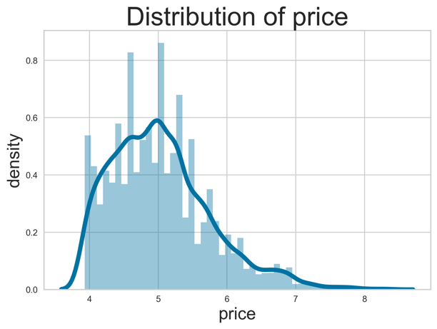

Figure 5-1 Distribution of price after log transformation

## 5.2 Numerical predictors

### 5.2.1 Converting numerical variable to categorical variable

*'accommodates', 'bathrooms', 'bedrooms', 'beds'* and *'guests_included'* are discrete variables with a few possible values which shows a categorical characteristic. Thus, we choose to convert those numerical variables into categorical and further engineering it in section 5.3.2.2.

### 5.2.2 Transforming Skewed Numerical Predictor

To ensure normal distribution of data, Yeo-Johnson method is applied numerical variables found to be right-skewed and have outliers. The reason that we use Yeo-Jonson is because this method has no restriction on the range of predictor, and it can directly make distribution as close to normal distribution as possible. Compared the log transformation in response variable engineering, there is no back transforming requirement for explanatory variables and Yeo-Johnson proves to be convenient and robust. The list of predictors transformed are:

|  |  |  |
| --- | --- | --- |
| *'security_deposit_perc'* | *'cleaning_fee_perc'* | *'extra_people_perc',* |
| *'availability_60'* | *'calculated_host_listings_count'* | *'number_of_reviews_ltm'* |
| *‘minimum_nights’* |  |  |

## 5.3 Categorical Predictor

### 5.3.1 Drop Variables

Based on EDA (section 4.3.1), *‘experiences_offer’,* ‘*required_license’,* and ‘*is_business_travel_ready*’ were found to have only one label, therefore are dropped from the dataset.

Furthermore, *‘required_gues_profile_pictures*’ have 10590 “t” against 45 “f” and ‘*require_guest_phone_verification*’ have 10577 “t” against 58 “f”. The low count of false in each of these variables provides minimal prediction value and are therefore dropped.

### 5.3.2 Merge Sparse Labels

#### 5.3.2.1 Normal Categorical Predictors

From Exploratory data analysis (4.3.1), there are some variables that have low label counts. For example, in categorical variable *‘bed_type’,* 99.6% of Airbnb properties are real bed. However, Pull-out sofa, couch, futon, and airbed only account for 0.4%. In this case, we can merge these low count labels into a category “Other”. Merging sparse labels could help to decrease the number of dummy variable, reduce the risk of overfitting. Based on count plots (see appendix L), merge methods are show in table 5-1:

|  |  |  |
| --- | --- | --- |
| Variable name | Original Labels | Merged Labels |
| *‘property_type’* | “House”, “Apartment”, “Cottage”, “Hotel”, “Loft”, “Island”, “earth house” …. | “House”, “Apartment” and “other” |
| *‘room_type’* | “Entire home\apt”, “Private Room”, “Hotel room”, “Shared room” | “Entire home\apt”, “Private Room”, “other” |
| *‘bed_type’* | “Real bed”, “Pull-out sofa”, “Couch”, “Futon”, “Air bed” | “Real bed” and “Others” |
| *‘cancellation_policy’* | “strict_14_with_grace_period”, “flexible”, “moderate”, “super_stric_60”, “super_strict_30”, “luxury_no_refund”, “luxury_moderate”, “luxury_super_strict_125”, “strict” | “Strict_14_with_grace_period”, “flexible”, “moderate” and “other” |

Table 5-1 Merge method

#### 5.3.2.2 Numerical variables that were transformed to categorical variables

After transforming these variables into categorical variables in section 5.1.1 and based on count plots (see appendix L), there are labels within each category which have a low count. To avoid overfitting, the variable will be merge like previous section:

|  |  |  |
| --- | --- | --- |
| Variable Name | Original labels | Merged labels |
| *'accommodates'* | 1, 2, 3, 4, 5, 6, 7, 8, 9, 10, 11, 12, 13, 14, 15, 16 | 1, 2, 3, 4, 5, 6, 7, 8,  9 or more |
| *'bathrooms'* | 0.0, 1.0, 1.5, 2.0, 2.5, 3.0, 3.5, 4.0, 4.5, 5.0, 5.5, 6.0, 6.5 | 0.0, 1.0, 1.5, 2.0, 2.5,  3.0 or more, |
| *'beds’* | 0.0, 1.0, 2.0, 3.0, 4.0, 5.0, 6.0, 7.0, 8.0, 9.0, 10.0, 11.0, 12.0, 14.0, 16.0 | 0.0, 1.0, 2.0, 3.0, 4.0, 5.0, 6.0, 7.0, 8.0 or more |
| *'guests_included'* | 1, 2, 3, 4, 5, 6, 7, 8, 9, 10, 11, 12, 13, 14, 15, 16 | 1, 2, 3, 4, 5 or more |
| *'bedrooms'* | 0.0, 1.0, 2.0, 3.0, 4.0, 5.0, 6.0, 7.0, 8.0, 9.0 | 0.0, 1.0, 2.0, 3.0, 4.0, 5.0 or more, |

Table 5-2 Merge Method

#### 5.2.2.3 Transform review score related variables to categorical variables

Following the rationale in data processing section (3.0), review scores are filled with the string “no review”. Therefore, amongst review scores, there are both float numbers and strings. The issue here is that since the string “no review” cannot be converted to float, other floats must be converted to strings and used as categories. However, direct dummy variable transformation of review scores will lead to high dimensionality due to wide range of numbers present. Therefore, we instead bin review scores into a range provided below such that “no review” can still be in its own category:

|  |  |
| --- | --- |
| Variable’s name | Binning Method |
| *‘review_scores_rating’* | “No Review”, “90-100”, “80-90”, “70-80” and “below 70”. |
| *‘house_response_rate’* | “Unknown”, “100”, “90-99”, “50-89” and “below 50” |
| *‘review_scores_checkin’* | “10”, “9”, “8” and “below 7” |
| *‘review_scores_communication’* | “10”, “9”, “8” and “below 7” |
| *‘review_scores_location’* | “10”, “9”, “8” and “below 7” |

Table 5-3 Binning Method

### 5.3.3 Transfer Categorical variable to numerical variable

‘*neighborhood_cleansed*’ have 38 labels and generalized linear mixed model (GLMM) encoder is logical to be used here as there is probable price discrepancies between councils. This encoding method converts categorical variable to numerical predictors by calculating the estimate deviation between the mean nightly rental price for that neighbourhood and the mean nightly rental price for all neighbourhoods (see figure 3-1).

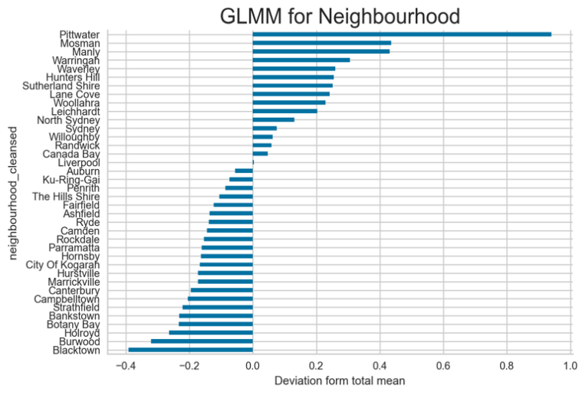

Figure 3-1: GLMM Graph

This aligns with expectations as affluent areas such as Pittwater are valued much higher than Blacktown which have lower socio-economic status.

### 5.3.4 Transforming text data to categorical variable

Amenities

Based on EDA (4.4.1), number of appearances of each unique amenities are extracted from the training data set. This is then sorted by number of appearances in a descending order. Next, to address high dimensionality from creation of dummy variables, we select the important amenities described by Airbnb’s official website (Airbnb, 2020). We then group similar amenities together to include more information within each category. For example, “*TV*” consist of “TV”, “Smart TV”, and “Cable TV” which are all TV related. The final encoding method is if the property contains one of the above amenities, the value of “*TV*” is equal to 1, otherwise the value is 0. Other amenities is combined and presented in Appendix R. This reduces what would have been 209 dummy variables to meaningful categories that only creates 25 dummy variables.

Interaction

According to the EDA (4.4.2), we decide to manually choose words in top 30 most frequent word list that host shows high enthusiasm to help the customers such as “available”, “help”, “assist” and “contact”. By using dummy encoding method, if the interaction section has one or more of these words, the host will be recognized as a host have a good interaction with customer and the value of “Interaction” is 1. Otherwise, the value is 0.

Neighbourhood_overview

Based on the EDA (4.4.2), the given information of neighbourhood overview could create a variable called “Airbnb’s close proximity to essentials”. This is because the information shows the availability of essential facilities within the neighbourhood. This is determined to include restaurants, cafes, shops, and bars. We create a dummy variable where 1 includes those facilities and 0 does not.

Transit

Based on the given information in EDA (4.4.2), transit shows the information of nearby transportation condition. Thus, we create dummy variable that shows whether the property have public transportation nearby. In the dummy variable, if the *‘transit’* has words “bus”, “station” and “train”, the value of *‘transit’* is 1. Otherwise, the value of *‘transit’* is 0.

### 5.3.5 Transforming date time object (12 years) to numerical predictor

Based on EDA (4.5), *‘host_since’* could convert into categorical variable with 12 different year labels from 2009 to 2020. However, when using dummy encoding, too many labels may result in high cardinality. Thus, we decide to turn the data time object into age. Age is interpreted as the relative length of time that Property owner become an Airbnb host in comparison of maximum year in the dataset.

### 5.3.6 One-hot encoding

Finally, all other categorical variables are transformed using one-hot encoding. Dummy variable is not used as there is no concern of multi-collinearity when using non-parametric models as well tree-based methods to perform better with one-hot encoding. This results in

# 6.0 Methodology

## 6.1 Overview

After exploratory analysis and feature engineering, 122 independent variables will be used to conduct modelling. The three models described in detail are:

1. Regularisation
2. XGBoost
3. Model stacking

Two models mentioned briefly are:

1. LightGBM
2. Gradient Boosting Machines

The model descriptions embedded by mathematical detail along with rationale and practical implementation to find optimal hyperparameters will be described below.

## 6.2 LASSO regression

### 6.2.1 Model description

Based on the linear regression model, the LASSO regression solves the penalised estimation problem:

$${\hat{β}}_{LASSO}=argmin_{β}\left\{{\sum_{i=1}^{N}{\left(y_{i}-β_{0}-\sum_{j=1}^{p}{β_{j}x_{ij}}\right)}}^{2}+λ\sum_{j=1}^{p}{{|β}_{j}|}\right\}$$

Instead of the learning algorithm (linear regression in this case) only minimising the training error, the addition of the penalty term allows the learning algorithm to balance between training error and model complexity. This will reduce overfitting by shrinking the coefficients of the linear regression, leading to a model with lower variance without accepting too much bias. The LASSO regularisation will be used as a benchmark for the more complex models in later sections.

### 6.2.2 Model rationale

The reason regularisation is an intuitive choice for our data set is because we have many features and model complexity is high when all the variables are used. By using LASSO regression, it is not only able shrink the coefficients towards zero but also perform variable selection. This is especially relevant as after dummy variable implementation where we have 84 columns of 0 and 1. This can be compared to the $l_{2}$ regularisation (i.e., Ridge regression) where the coefficients are only shrinking towards zero and no variables selection occurs.

### 6.2.3 Practical implementation

Firstly, both explanatory variables and the response variable are scaled to eliminate the influence of unit and scale and RubustScaler is chosen. Since RobustScaler transforms the feature vector by subtracting the median and then dividing by the interquartile range, it is robust to outliers in particular. This had been case for many numerical variables even after the initial Yeo-Johnson transformation. Ultimately, it will ensure every variable have a fair and robust shrinkage.

Next, the hyperparameter $λ$ is chosen based on 5-fold cross validation (CV). We generated a list of lambdas using Euler’s number to the power of a range between -20 and 0. This index range is increased by increments of 0.02 and was chosen to observe the impact of lambda at different log scales. After lambda is chosen based on CV, we fit a LASSO linear regression model using all of standardised predictors. The optimal lambda chosen is $2.747×{10}^{-4}$.

### 6.2.4 Interpretations of the models

At the optimal CV lambda of $2.747×{10}^{-4}$, there are 30 features which shrank to zero and by sorting the coefficient in absolute terms, the top five feature that are most important according to LASSO regression are:

|  |  |
| --- | --- |
| Variables Name | Importance |
| *‘accommodates_9 or more’* | 0.479 |
| *‘accommodates_1’* | 0.470 |
| *‘accommodates_8’* | 0.360 |
| *‘bathrooms_3.0 or more’* | 0.350 |
| *‘accommodates_2’* | 0.319 |

Table 6-1 Top five important features in LASSO regression

Obviously, this states that the number of accommodates and 3 or more bathrooms to be the most important in deciding nightly rental price. However, this is not informative as since we transformed the continuous variable such as accommodates (see section 5.2.1) to categorical variables, it had flooded the top 5 list because of the dummy variable transformation. Therefore, accounting for this, the top 5 features without absolute values are presented below:

|  |  |
| --- | --- |
| Variables Name | Importance |
| *‘accommodates’* | - |
| *‘bathrooms_3.0 or more’’* | 0.350 |
| *‘room_type_private_room’* | -0.289 |
| *‘cancellation_policy_others’* | 0.219 |
| *‘yeo_Johnson_Cleaning_fee_perc’* | -0.210 |

Table 6-2 Top five important feature in LASSO regression after justification

While accommodate and bathrooms are intuitive, private room leads to lower price prediction as here private room refers to a singular room in a shared house. Cancellation policy others includes cancellation policies that are super strict and is positive. This opposes common understanding that more flexible policy is reflected in higher price. However, an explanation here might be that cancellation policies that are super strict are often places with high reservations, likely to be tourist hotspots that is expensive in price. Finally, cleaning fee percentage is negative as because the feature is in percentage terms, if cleaning fee remains constant and cleaning fee percentage increase, it implies the nightly rental prices decrease. Through Robust scaler and log transformation of the response variables, coefficient values itself are therefore difficult to interpret. This highlights the disadvantage of LASSO regression compared to a simpler linear regression.

## 6.3 XGBoost

### 6.3.1 Gradient boosting machine description

Prior to understanding XGBoost, one must first understand gradient boosting machines (GBM). GBM is an ensemble learning technique that combines many machine learning techniques and it is the basis for XGBoost. Since our problem is a regression problem, the least squares boosting minimisation problem is:

$$\begin{matrix}minimise \\ θ_{m}\end{matrix}\left\{\sum_{i=1}^{n}{{\left(y_{i}-f_{m-1}\left(x_{i}\right)-T\left(x_{i};θ_{m}\right)\right)}^{2}}\right\}$$

Specifically, at the $i^{th}$ iteration, this can be interpreted as fitting a regression tree $T\left(x_{i};θ_{m}\right)$ to the residual of the current model $\left(y_{i}-f_{\left(m-1\right)}\left(x_{i}\right)\right)$. Hence, the key issue is how to fit the optimal decision tree. If we were given regions for the decision tree, the optimal prediction for each leaf is straightforward by computing:

$${\hat{w}}_{jm}=\begin{matrix}argmin \\ w\end{matrix}\left\{\sum_{x_{i}∈R_{jm}}{L\left(y_{i},f_{m-1}\left(x_{i}\right)+w\right)}\right\}$$

The difficulty remains on how to find the optimal regions or optimal tree structure, and this is where GBM excels. Considering the gradient descent algorithm, GBM induce a tree $T\left(x_{i};θ_{m}\right)$ that approximates the negative gradient of the loss function. This $g_{im}$ is equal to $y_{i}-f_{m-1}\left(x_{i}\right)$ for the squared error loss function and therefore, by approximating the gradient function, we approximate the solution to least squares boosting minimisation problem at each iteration.

### 6.3.2 XGBoost

Extreme Gradient Boosting (XGBoost) is a successful implementation of gradient boosting and differs in:

1. XGBoost is utilises a second order approximate of the loss function at each iteration
2. Regularises the predictions at the leaves
3. Prunes the trees

It solves the following regularised risk minimisation problem:

$$\begin{matrix}minimise \\ θ_{m}\end{matrix}\left\{\sum_{i=1}^{n}{L\left(y_{i}, f_{m-1}\left(x_{i}\right)+T\left(x_{i};θ_{m}\right)\right)+Ω\left(θ_{m}\right)}\right\}$$

Where $Ω\left(θ_{m}\right)$ penalises the complexity of the new tree $T(x_{i};θ_{m})$.

### 6.3.3 Model rationale

In general, gradient boosting machines are preferred for our data set because its accuracy and training speed is superior in the training of large dataset. It effectively incorporates the advantage of regression trees which are robust to outliers and natural handing of multiple data types. Furthermore, decision trees are insensitive to monotone transformations of numerical predictors which means we do not need to create a new file due to the feature engineering features we have conducted for LASSO regression. Finally, trees can perform automatic variable selection as well as modelling interactions.

Within variants of gradient boosting machines however, we have chosen to write XGBoost in detail over GBM is because its regularisation term is able to effectively reduce overfitting. Furthermore, its second order approximate of the squared loss significantly reduces computation complexity. Finally, with a NVIDIA graphics card, my team’s GTX2060 graphics card is able to capitalise on XGBoost’s in built support. With training objective of squared error which have a constant hessian, changing the tree method to “gpu_hist” is preferred as weighted sketching in “approx” does not make sense with constant weights. Here, sketching refers to process where XGBoost handles weighted data for point splitting of regression trees. XGBoost is chosen to explore in detail over LightGBM, its leaf-wise split brother, because of superior cross validation performance.

### 6.3.3 Bayesian optimisation for hyperparameter tuning

Due to the proliferate number of hyperparameters for XGBoost, our team had decided to define a search space and tune the hyperparameters using Bayesian optimisation. Bayesian optimisation uses the posterior distribution to create a surrogate objective function. The surrogate function provides regions for promising local minima and further sampling using the acquisition function is conducted for those regions. The surrogate function then updates its data to provide a better approximation of the objective function.

Its main advantage in its implementation of hyperparameter tuning is it greatly reduces computation complexity due to Bayesian approximations. Furthermore, it will not be “trapped” in a local minimum, finding better approximations that is closer to the global minimum. Therefore, Bayesian optimisation encompasses the advantage of reduced complexity from randomised search while provides a promising set of hyperparameters that is close to the best set provided by grid search.

The best set of hyperparameters for XGBoost using a 5-fold cross validation at 10 iterations of Bayesian optimisation is displayed below:

|  |  |
| --- | --- |
| Colsample_bytree | 0.258 |
| Learning rate | 0.024 |
| Max_depth | 5.000 |
| N_estimators | 2603.000 |
| Reg_lambda | 3.196 $×{10}^{-4}$ |
| Subsample | 0.605 |

Table 6-3 Hyperparameters of XGBoost

### 6.3.4 Model interpretation

Since XGBoost is a non-parametric model, interpretations of model parameters are difficult. However, we can extract the top five important features through using the function “xgboost.get_booster().get_score(importance_type = ‘gain’). This evaluates the relative contribution of the corresponding feature to the model. Specifically, the relative contribution is defined by the improvement in accuracy by utilising the feature at a new split. These are the top 5 features:

|  |  |
| --- | --- |
| Variable Name | Score |
| *‘room_type_private room’* | 14.039 |
| *‘bedrooms_3.0 or more’* | 9.815 |
| *‘room_type_entire home/apt’* | 8.938 |
| *‘bedrooms_1.0’* | 8.553 |
| *‘beds_1.0’* | 6.318 |

Table 6-4 Top 5 important feature in XGBoost using ‘gain’

Another feature importance type is ‘weights’, and it evaluates importance by the number of times a feature is used to split the data across all trees. The top 5 features are presented below:

|  |  |
| --- | --- |
| Variable Name | Score |
| *‘yeo_johnson_cleaning_fee_perc’* | 4,318 |
| *‘GLMM_neighbourhood’* | 4,029 |
| *‘yeo_johnson_security_deposit_perc’* | 3,862 |
| *‘Maximum nights’* | 3,847 |
| *‘Minimum nights’* | 3,636 |

Table 6-5 Top 5 features in XGBoost using ‘weight’

From the above (table 6-4 & 6-5), we can see that the results are quite different, but we argue ‘gain’ to be a better representation of feature importance as it measures the relative contribution of each variable. A common theme with LASSO regression that the model had also determined is the high influence of ‘room_type_private room’ and ‘bathrooms_3.0 or more’. Furthermore, similar to LASSO regression, features related to headcount such as bedrooms continuous to be important features. This aligned with our exploratory data analysis where these factors have a strong linear relationship with price (see section 4.2.2).

## 6.4 Model stacking

### 6.4.1 Model description

Model stacking is an ensemble learning method that specifies a meta-model that uses predictions from different models as features. In other words, prediction results from other models are trained as features using the level 2 model (i.e. metal model) based on cross validation.

### 6.4.2 Model rationale

Model stacking is used as it will provide good generalisation performance through considering prediction from multiple models. However, the key choice is the selection of the meta model as complex meta-models have higher risk of overfitting the validation set as well as decreasing interpretability. The meta regressor therefore chosen is linear regression as it closely mimics the weighted average meta regressor. The three level one estimators chosen are XGBoost, LightGBM and Gradient Boosting Machine. The reason for leaving out LASSO regression is explained below.

### 6.4.3 Model interpretation

Through using the aforementioned level one estimator and linear regression as meta regressor, we obtain the following coefficients for the three models:

|  |  |
| --- | --- |
| Model | Weighting |
| XGBoost | 0.649 |
| Gradient boosting machine | 0.019 |
| LightGBM | 0.339 |

Table 6-6 Weights in model stacking

Therefore, through cross validation and fitting the level one model’s prediction using linear regression, it reflects that the XGBoost having the most important prediction. This is followed by LightGBM and finally gradient boosting machine with a mere 0.019. Since, it was trained using the data, this hierarchy follows the order train RMSLE as we have reported in section 6.5. Essentially, the linear regressor maximises the weighting of the model with the best predictive power. This thus also explain why LASSO regression is left out. After experimentation, we found the LASSO prediction had a weight close to zero after using 5-fold cross validation. In terms of business context, it is important to note that model stacking is done solely for the purpose to reduce individual model bias and improve generalisation error. Prior important features within XGBoost and LightGBM still remains valid.

## 6.5 Model validation

Figure 6-1 Model Validation

Table 6-7 Model validation

|  |  |  |  |
| --- | --- | --- | --- |
|  | Train RMSLE | Cross validation RMSLE | Kaggle RMSLE |
| LASSO regression | 0.401 | 0.405 | 0.408 |
| XGBoost | 0.193 | 0.325 | 0.328 |
| Gradient boosting machine | 0.273 | 0.333 | 0.329 |
| LightGBM | 0.208 | 0.331 | 0.331 |
| Model stacking | 0.210 | 0.323 | 0.326 |

Looking at Kaggle root mean squared log error (RMSLE), we can see that model stacking performed the best out of the five models. This largely falls within expectation as using model stacking will improve generalisation ability through reducing the biases within the three gradient boosting model. Next, all three gradient boosting algorithms performed better than our benchmark model LASSO regression. Gradient boosting performed better as through using multiple weak learners (i.e. regression trees) it increased its model capacity and residual reduction at each iteration. This is more robust for a data with high dimensionality after feature engineering such as our one compared to LASSO regression which only shrank linear regression parameters through $l_{1}$ regularisation.

Finally, performance variance between the three gradient boosting models is explained. Between XGBoost, the best performing gradient boosting model, and gradient boosting machine, XGBoost inclusion of penalty term prevented overfitting to an extent. This can be seen on both of XGBoost’s cross validation RMSLE and Kaggle RMSLE slightly lower than gradient boosting machine. The main explanation here is that level wise growth usually performs better than leaf wise growth for small data sets. Our data set of 10635 data entries is not exactly considered “large” and therefore lightGBM performed worse as its specialty in treating large dataset is not capitalised. This is also reflected in lower wall time of XGBoost in hyperparameter tuning (12min 24sec) compared to lightGBM (46.7s) despite running similar number of iterations and over similar search space.

# 7.0 Data mining – What are the best hosts doing?

In parallel to problem formulation, this report will redefine the question “what are the best hosts doing?” to:

* Given the current structural conditions of the property, what actions are the best hosts undertaking to maximise their revenue?

This allows for a clearer definition on the actions that best host undertake to maximise their nightly rental price while sustaining a high occupancy rate. To explain, an Airbnb with three or more bedrooms would obviously cost more nightly than a one bedroom. However, it would be false to say that the best hosts have three or more bedrooms and therefore hosts with one bedroom must upgrade, renovate, or reinvest for a three-bedroom housing. This hence reflects the restrictions that actions are undertaken upon current structural conditionals of the property and are actions that are taken in the immediate future. To reformulate this to be a machine learning problem, we explore options amongst plain explanatory data analysis, supervised and unsupervised learning. Furthermore, in consideration to our redefined question, we therefore initially define the best host as those who maximise their renting price without affecting demand.

## 7.1 Methodology rationale

The first approach our team considered is to cluster the training data set based off one criterion that groups who are the “best hosts”. Further exploratory data analysis and unsupervised learning is then conducted to discover common characteristics or features in the “best host” group. Finding the “best hosts” from a financial perspective is troublesome as there are no information on both revenue and occupancy rate. The naive method is to sort the data set by descending order using nightly rental price and conduct further analysis on for example the top 10 percentile. Aforementioned, this would be invalid as one would expect it to be concentrated by houses with many bedrooms. Other sorting ideas might be dividing nightly rental price by bedrooms, but it does not exclude the effect of other structural factors (e.g., bathroom or neighbourhood). There would have to be a design of an aggregate score based on the structural features of the housing in which nightly rental price would have to be adjusted upon. This process, however, we deem to be complex and extremely bias in its formulation.

Therefore, after research, we have decided to instead formulate the following problem that acts as a proxy for our original question:

* What are the most important features in predicting the host to be a “super host”?

Our methodology to answer, “what are the best hosts doing?” is therefore formulated to be a supervised learning classification problem. The reason why we think this question is effective in addressing the question is based on the following three dimensions:

1. **Superhost is representative of best host**

From our problem definition we define best host to be those that maximise their renting price without affecting demand. This would imply that they maximise nightly rental price and occupancy at the same time to maximise revenue. Research have indicated that super hosts charge less on a nightly basis but have 81% higher occupancy rate compared to regular hosts, concluding super hosts to find a good balance between occupancy and nightly rate (Shatford, 2018). This finding is important as it suggest super host maximise their revenue, proving them to be best hosts and filling the gaps in our data availability.

1. **Feature importance in discovering insight**

Through formulating a classification problem, it enables the use of multiple model’s feature importance function. The models to be used are

* XGBoost classifier
* LightGBM classifier

The most important features in predicting whether the host is a “super host” would therefore be the actions that the best host is doing. To highlight, the main advantage of multiple models is that we can cross check recurring themes between model’s feature importance. It is important to note that there is a selection process where certain features are not included in the model. These are structural related factors and those we deem is not an action in the short term. This will further be explored in section 7.3.

1. **Abundance of data and ease of adjustment**

Without occupancy rate and revenue, the utilisation of *‘host_is_superhost’* that does not have missing value effectively proxies the best host, providing us with abundance of data (10,635 data points in training). Furthermore, super hosts are characterised officially by Airbnb with the following characteristics:

1. Completed at least 100 nights of reservations.
2. Maintained a 4.8 review rating last twelve month
3. Maintained over 90% response rate
4. Under 1% cancellation rate

While the last two are more explicit actions of super hosts, we want to find further insights that causes the first two to occur. Thus, because of effective full utilisation of training data and clear consideration and adjustment to final conclusion of insights, the reformulation of classifying whether a host is super host is a robust way to find insights regarding what the best host are doing.

## 7.2 Exploratory data analysis

Considering the model we will implement, XG Boost and Light GBM which can handle missing data automatically, we decide not to fill missing data in this case. Nevertheless, EDA had been radically changed due to the response now being *‘host_is_superhost’*, a categorical variable. A short EDA had been written.

### 7.2.1 Response Variable

Count plot (see Appendix S) is drawn to visualize the counts of regular host and super host. There are 9,060 regular hosts and 1,575 super hosts, where the proportion of super host is only 14.81%. The imbalance of class embedded in the dataset may lead to model cheating when we build the classification model.

### 7.2.2 Numerical explanatory variables vs. response variable

We have already examined the univariate numerical distribution in section 4.2.1, we will focus on bivariate relationships in this section. Logistics regression fitted line plots (see appendix T) between each numerical explanatory with ‘*host_is_superhost’* are drawn to visualize their relationships. Each plot includes a regression line, which represents the regression equation. In this case, the equation gives the probability that a host is a super host.

From the regression lines in plots, we see that the variables that have relatively strong predictive power in classifying are:

* ‘guests_included’
* ‘extra_people_perc’
* ‘number_of_reviews’
* ‘reviews_per_month’

When those variables increase, the probability that the host is a super host increase as well. Especially, ‘*number_of_reviews’* has the steepest slope, indicating that the probability increases fast as *‘number_of_reviews’* increases.

Otherwise, all other variables show little predictive power in classifying whether a host is a super host because their regression lines are flattened around zero probability.

### 7.2.3 Categorical explanatory variables vs. response variable

Similarly, while the univariate categorical variables remain the same, bivariate relation changes. Bar charts are drawn to visualize the proportion of super hosts in each category of each categorical variables. Appendix U present the bar charts for categorical variables that have relatively large differences between proportions in each category. Table 7-2-3 summarises those categorical variables:

|  |  |  |  |
| --- | --- | --- | --- |
| Neighbourhood cleansed | Property type | Room type | Bed type |
| Require guest profile picture | Require guest phone verification | Cancellation policy | Host response time |

Table 7‑2-3 Summary of categorical variable that have large impact on predicting host is super host

For example, in *‘neighbourhood_cleansed’*, the proportions of super hosts in Pittwater and Penrith are much larger than in other neighbourhoods. What is more, in *‘require_guest_profile_picture’*, the proportion of super hosts when it is true is much larger than it is false.

## 7.3 Feature engineering and the feature selection criterion

Feature engineering remains largely the same as predicting nightly rental prices except with the key change in using the python package ‘Toad’ for dealing with categorical variables with high cardinality (i.e. ‘*neighourhood_cleansed’*). In summary, this package performs chi-squared binning on *‘neighbourhood_cleansed’*, resulting in five categories that is ordered by their proportion of super hosts. We use the bin labels to transform ‘*neighourhood_cleansed’* into ordinal features (0-5) as the labels indicating their ranking in proportions of super hosts, thus ordinal mapping can extract this important information and also reduce dimensionality. Appendix V is the summary of binning result on ‘*neighourhood_cleansed’*. Penrith and Pittwater are transformed to ordinal feature ‘5’, indicating they have the highest proportion of super hosts, this is also evident in section 7.2.3. We also use the ‘Toad’ to perform chi-squared binning on *‘cancellation_policy’*, and appendix W summarizes the transformation.

Finally, since our problem are defined to be short term actions that the host can immediately take, a list of variables is removed from the final features list. These includes *‘property_type’* and *‘room_type’* where we deem it is a structural factor instead of an action the host can take. Furthermore, variables such as *‘review_per_month*’ is also removed due to them being action not being initiated by the host. For the full list variables that is chosen see appendix X.

## 7.4 Model evaluation

Since the key objective is to find useful insight through feature importance, model accuracy is a lesser concern. We argue that having the most accurate model will not change the order of feature importance based on ‘gain’ greatly. Therefore, both cross validation and hyperparameters tuning are omitted. As a compensation, we have chosen XGB classifier and LightGBM classifier to utilise their inbuilt regularisation term, implicitly reducing overfitting. Furthermore, the list of top 16 features will be cross checked to discover common theme between them.

## 7.5 Final insights discovered

Using feature importance with method being ‘gain’ similar to that of nightly rental price prediction, the top 16 feature importance for XGBoost classifier and LightGBM classifier is displayed below:

|  |  |  |
| --- | --- | --- |
| Ranking | XGBoost | LightGBM |
| 1 | *‘review_scores_accuracy’* | *‘host_acceptance_rate_float’* |
| 2 | *‘host_acceptance_rate_float’* | *‘review_scores_accuracy’* |
| 3 | *‘host_response_rate’* | *‘host_response_rate’* |
| 4 | *‘review_scores_cleanliness’* | *‘review_Scores_cleanliness’* |
| 5 | *‘hair Dryer’* | *‘host_since_age’* |
| 6 | *‘review_scores_communication’* | *‘price’* |
| 7 | *‘bed linens’* | *‘cleaning_fee_perc’* |
| 8 | *‘weekly_discount’* | *‘security_deposit_perc’* |
| 9 | *‘sanity’* – Body Soap and Shampoo | *‘maximum nights’* |
| 10 | *‘review_scores_checkin’* | *‘extra_people_perc’* |
| 11 | *‘host_repsonse_time_within_an_hour’* | *‘minimum nights’* |
| 12 | *‘monthly_discount’* | *‘review_scores_communication’* |
| 13 | *‘host_since_age’* | *‘neighbourhood_Cleansed_bins’* |
| 14 | *‘toilet_paper’* | *‘host_response_time_within an hour’* |
| 15 | *‘kitchen’* | *‘bed linens’* |
| 16 | *‘WIFI’* | *‘hair Dryer’* |

Table 7-2 Top 16 important Features in XGBoost and LightGBM

From the above we have highlighted the common themes between the two model and its derived insight will be presented below. It is important to note, since we already know four criteria for becoming a super host, two top factors had been determined to not a be an action that the host can do to maximise profit. Host acceptance rate is removed as it would directly relate to number of nights of reservations. This would increase occupancy rate and therefore we determine this factor to be too direct and providing insufficient insight to the question. Another factor that had been removed is host response rate as Airbnb explicitly states it to be a super host criterion. It also directly translates to sales and therefore determined to not be an insight.

### Insight 1: Customers value accuracy over all other review score ratings

While Airbnb directly states super host to have review scores ratings above 4.8, the order of review scores is an important insight that is not revealed to us previously. From first ranking in XGBoost and second ranking in LightGBM, customers appear to value accuracy over all other review score ratings. This could be explained by if a host is accurate about their offerings, it is most likely to increase their occupancy rate in two ways through:

1. Repeated customers as they had a rewarding experience at the property given the offline property had closely matched online description. The host is trustworthy.
2. New customers as it may be inferred reliability and trustworthiness of the host is something to be highly valued when after they read the review of old customers to determine their renting option.

Even if the nightly rental price may be low for a host, as long as their online description is accurate, customers may determine the offering to be worthy at the price point, causing the occupancy rate or volume of sales can remain high.

### Insight 2: Hygiene is extremely important with sanity amenities and cleanliness of the property

The second theme that appears after accuracy is hygiene reflected by hygienic amenities (e.g. body soap and shampoo) and high ranking of review score cleanliness. The direct competitors of Airbnb are hotels and the standardised cleaning at hotels are value highly by all renters. Thus, equal expectation would be applied to Airbnb properties, highlighting the importance of a hygienic environment. Further investigation would be needed regarding whether a higher cleaning fee percentage translate into a more hygienic property but what is most important is that hosts are keeping their properties clean.

### Insight 3: Other two key amenities are having a hair dryer and bed linens

Finally, the top two key amenities that appears aside of hygiene are a hair dryer and a bed linen. While basic, it is an essential that is often offered across hotels. The peace of mind in which a renter’s luggage would not have to include a hair dryer and bed linen is valued highly.

# 8.0 Conclusion

In conclusion, appropriately valued nightly rental price against market prices is able to maximise the occupancy rate through providing the host with an anchor for pricing. Their price is not out of the range for properties of similar characteristics, increasing the probability in which a customer will choose their property based on the price offered. Finally, the three insights resulting from data mining are crucial in hosts further ensuring occupancy rate is sustained and nightly rental price maximised.

# 9.0 References List

Airbnb. (2020). The amenities guests want - Resource Centre. *Airbnb*.

https://www.airbnb.com.au/resources/hosting-homes/a/the-amenities-guests-want-25?_set_bev_on_new_domain=1620027778_NDA1YzE4OTZiNTk3 Retrieved on: 01/05/2021

Shatford, S. (2021, March 16). What is Airbnb’s Superhost Status Really Worth? *AirDNA - Short-Term*

*Vacation Rental Data and Analytics*. https://www.airdna.co/blog/airbnb_superhost_status Retrieved on: 17/05/2021

# 10.0 Appendix

**Appendix A: Summary of explanatory variables**

|  |  |
| --- | --- |
| Text | name, summary, space, description, neighborhood_overview, notes, transit, access, interaction, ‘house_rules’, host_about, host_verifications, amentities |
| Categorical | experiences_offered, host_since, host_location, host_response_time, host_response_rate, host_acceptance_rate, host_is_superhost, host_neiborhood, host_identity_verified, street, neighbourhood, neighbourhood_cleansed, city, zipcode, smart_location, is_location_exact, property_type, room_type, bed_type, first_review, last_review, requires_license, instant_bookable, is_business_travel_ready, cancellation_policy, require_guest_profile_picture, require_guest_phone_verification, |
| Numerical | host_id, host_listings_count, host_total_listings_count, latitude, longtitude, accommodates, bathrooms, beds, square_feet, weekly_discount, monthly_discount, security_deposit_perc, cleaning_fee_perc, guests_included, extra_people_perc, minimum_nights, maximum_nights, minimum_minimum_nights, maximum_minimum_nights, minimum_maximum_nights, maximum_maximum_nights, minmum_nights_avg_ntm, maximum_nights_avg_ntm, availability_30,  availability_60, availability_90, availability_365, number_of_reviews, number_of_reviews_ltm, review_scores_rating, review_scores_accuracy, review_scores_cleanliness, review_scores_checkin, review_scores_communication, review_scores_location, review_scores_value, calculated_host_listings_count, calculated_hosted_listings_count_entire_homes, calculated_hosted_listings_count_private_rooms, calculated_hosted_listings_count_shared_rooms, reviews_per_month |

**Appendix B: Correlation matrix for review score related variables**

|  |  |
| --- | --- |
| Variable Name | Review_scores_rating |
| ‘Review_scores_accuracy’ | 0.751 |
| ‘Review_scores_cleanliness’ | 0.725 |
| ‘Review_scores_checkin’ | 0.572 |
| ‘Review_scores_communication’ | 0.637 |
| ’Review_scores_locationn‘ | 0.474 |
| ‘Review_scores_value’ | 0.725 |

**Appendix C: Summary of missing data**

|  |  |  |
| --- | --- | --- |
| Variable Name | Number of Missing Items | Missing Percentage |
| ‘Square_feet’ | 10,573 | 99% |
| ‘Monthly_discount’ | 10,115 | 95% |
| ‘Weekly_discount’ | 9,787 | 92% |
| ‘Host_response_rate’ | 4,587 | 43% |
| ‘Host_response_time’ | 4,587 | 43% |
| ‘Interaction’ | 4,127 | 39% |
| ‘Neighbourhood_overview’ | 3,662 | 34% |
| ‘Transit’ | 3,573 | 33% |
| ‘Host_acceptance_rate’ | 3,554 | 33% |
| ‘Security_deposit_perc’ | 3,476 | 33% |
| ‘Review_scores_checkin’ | 2,998 | 28% |
| ‘Review_scores_location’ | 2,997 | 28% |
| ‘Review_scores_communication’ | 2,989 | 28% |
| ‘Review_scores_rating’ | 2,982 | 28% |
| ‘Cleaning_fee_perc’ | 2,576 | 24% |
| ‘Beds’’ | 66 | 0.6% |
| ‘Bedrooms’ | 5 | 0.05% |
| ‘Bathrooms’ | 4 | 0.04% |

**Appendix D: Distribution of response variable price**

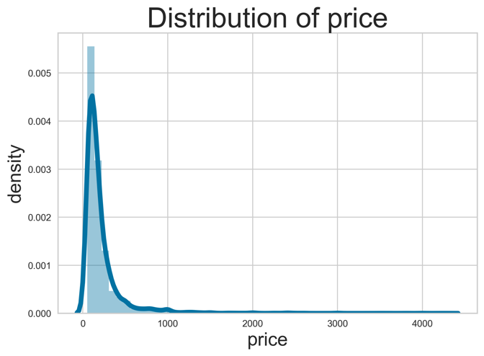

**Appendix E: Summary statistics about response variable price**

|  |  |  |  |  |  |  |  |  |  |
| --- | --- | --- | --- | --- | --- | --- | --- | --- | --- |
| Feature | Mean | Standard Deviation | Min | 25% | 50% | 75% | Max | Skewness | Kurtosis |
| Price | 212.37 | 255.62 | 51.00 | 89.00 | 144.00 | 231.00 | 4300.00 | 5.70 | 52.60 |

**Appendix F: Distributions of numerical explanatory variables**

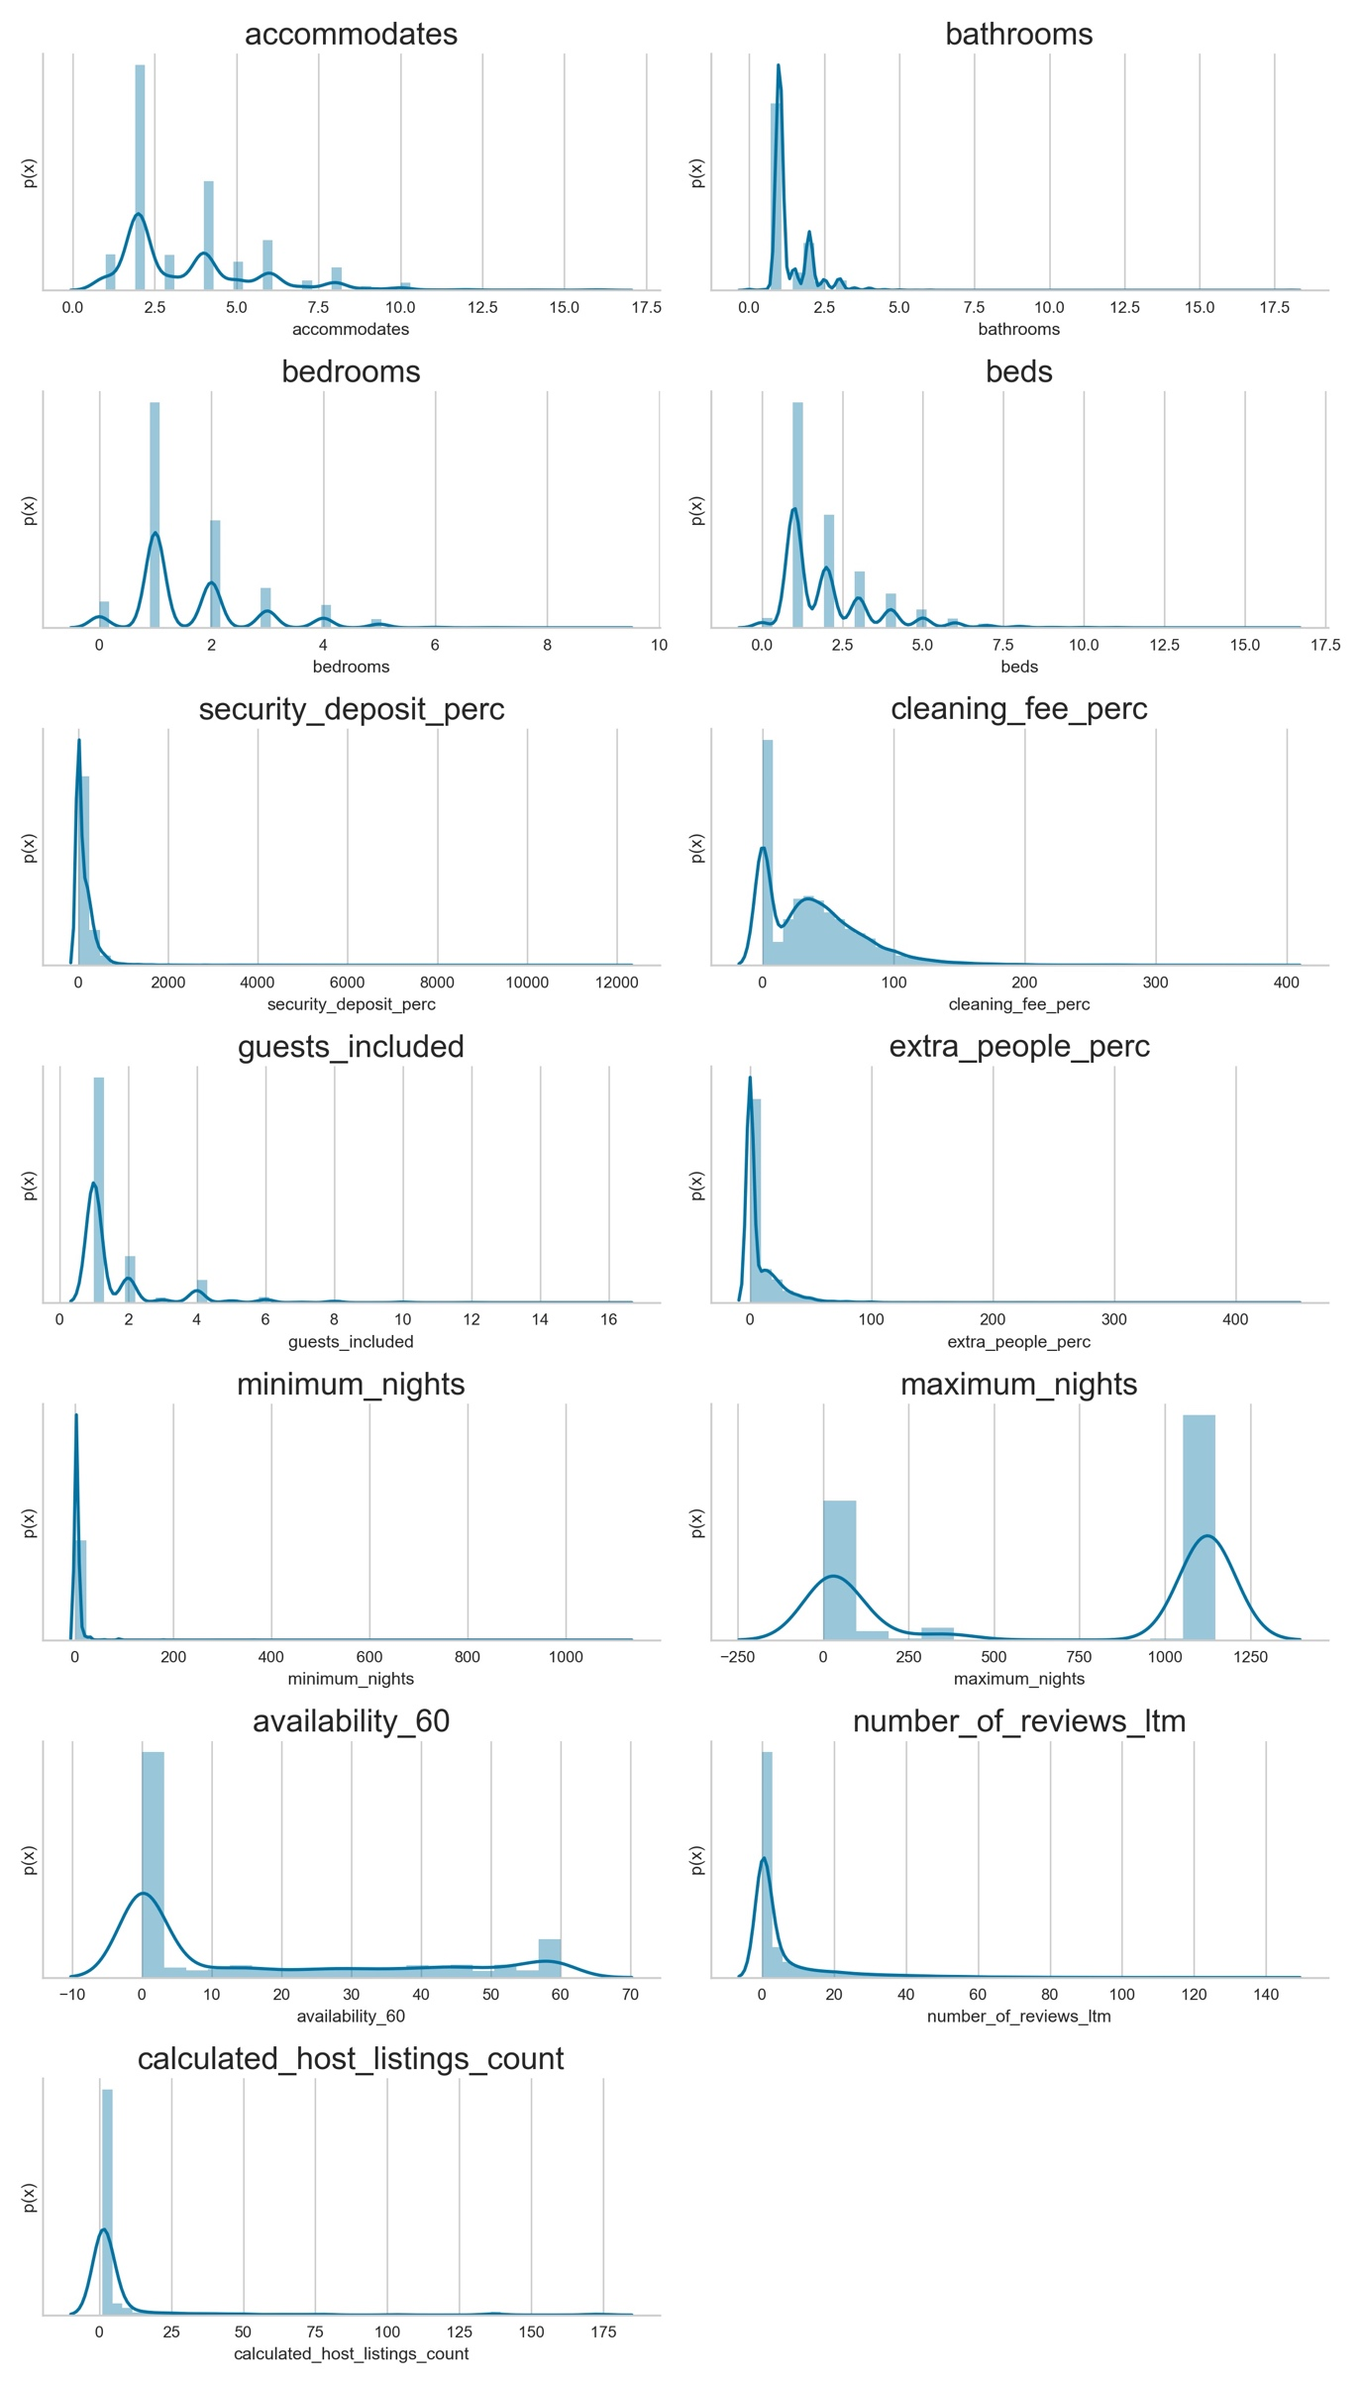

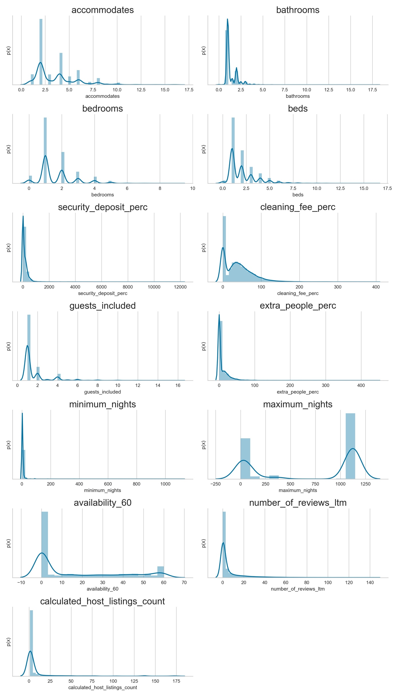

**Appendix G: Summary statistics for discrete numerical variables**

|  |  |  |  |  |  |  |  |
| --- | --- | --- | --- | --- | --- | --- | --- |
| Feature | Mean | Standard Deviation | Min | 25% | Median | 75% | Max |
| Accommodates | 3.58 | 2.26 | 1.00 | 2.00 | 3.00 | 3.00 | 16.00 |
| Bathrooms | 1.38 | 0.74 | 0.00 | 1.00 | 1.00 | 2.00 | 18.00 |
| Bedrooms | 1.63 | 1.09 | 0.00 | 1.00 | 1.00 | 2.00 | 9.00 |
| Beds | 2.05 | 1.53 | 0.00 | 1.00 | 2.00 | 3.00 | 16.00 |
| Guest_included | 1.66 | 1.43 | 1.00 | 1.00 | 1.00 | 2.00 | 16.00 |

**Appendix H: Distribution for security deposit perc and cleaning fee perc**

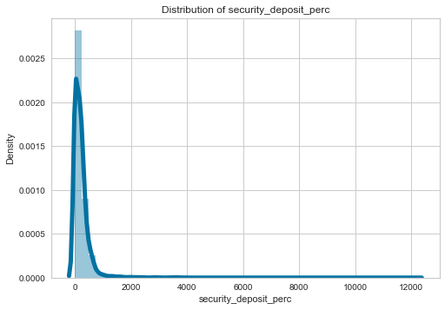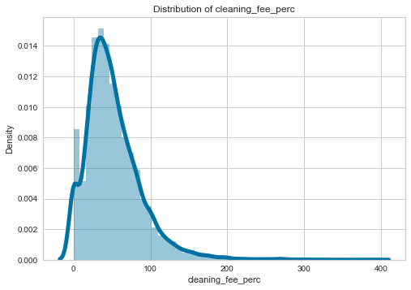

**Appendix I: Summary statistics for continuous numerical variables**

|  |  |  |  |  |  |  |  |  |  |
| --- | --- | --- | --- | --- | --- | --- | --- | --- | --- |
| Feature | Mean | Standard Deviation | Min | 25% | Median | 75% | Max | Skewness | Kurtosis |
| ‘Security deposit perc’ | 147.56 | 358.99 | 0 | 0 | 0 | 208 | 12,167 | 14.01 | 322.64 |
| ‘Cleaning fee perc’ | 39.15 | 38.46 | 0 | 0 | 34 | 60.00 | 392 | 1.44 | 4.05 |
| ‘Extra people perc’ | 8.76 | 19.37 | 0 | 0 | 0 | 13 | 444 | 6.89 | 95.62 |
| ‘Minimum nights’ | 5.14 | 20.86 | 1 | 1 | 2 | 5 | 1,125 | 30.55 | 1,351.96 |
| ‘Maximum nights’ | 680.09 | 527.07 | 1 | 30 | 1,125 | 1,125 | 1,148 | -0.37 | -1.83 |
| ‘Availability 60’ | 16.82 | 21.74 | 0 | 0 | 0 | 35 | 60 | 0.87 | -0.86 |
| ‘Calculated host listings count’ | 7.87 | 23.33 | 1 | 1 | 1 | 3 | 174 | 5.01 | 27.23 |
| ‘Number of reviews ltm’ | 6.48 | 13.72 | 0 | 0 | 1 | 5 | 143 | 3.40 | 15.05 |

**Appendix J: Scatter plots between numerical explanatory variables and price**

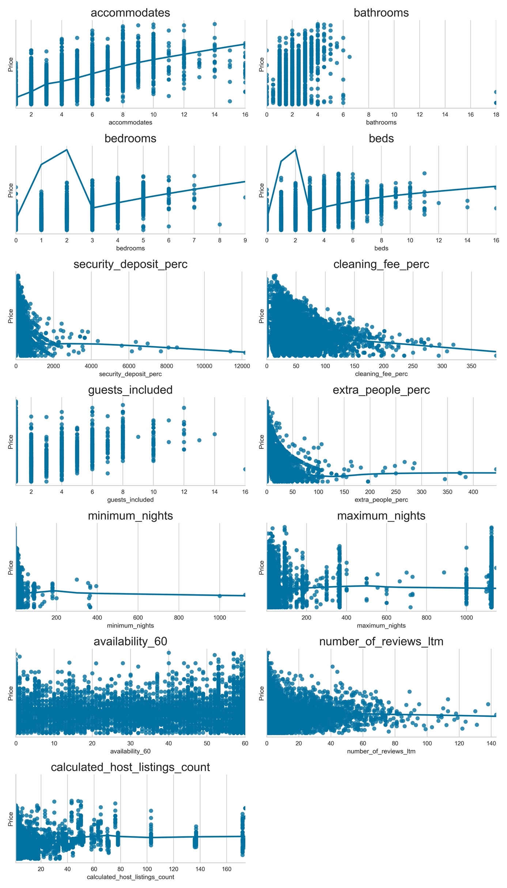

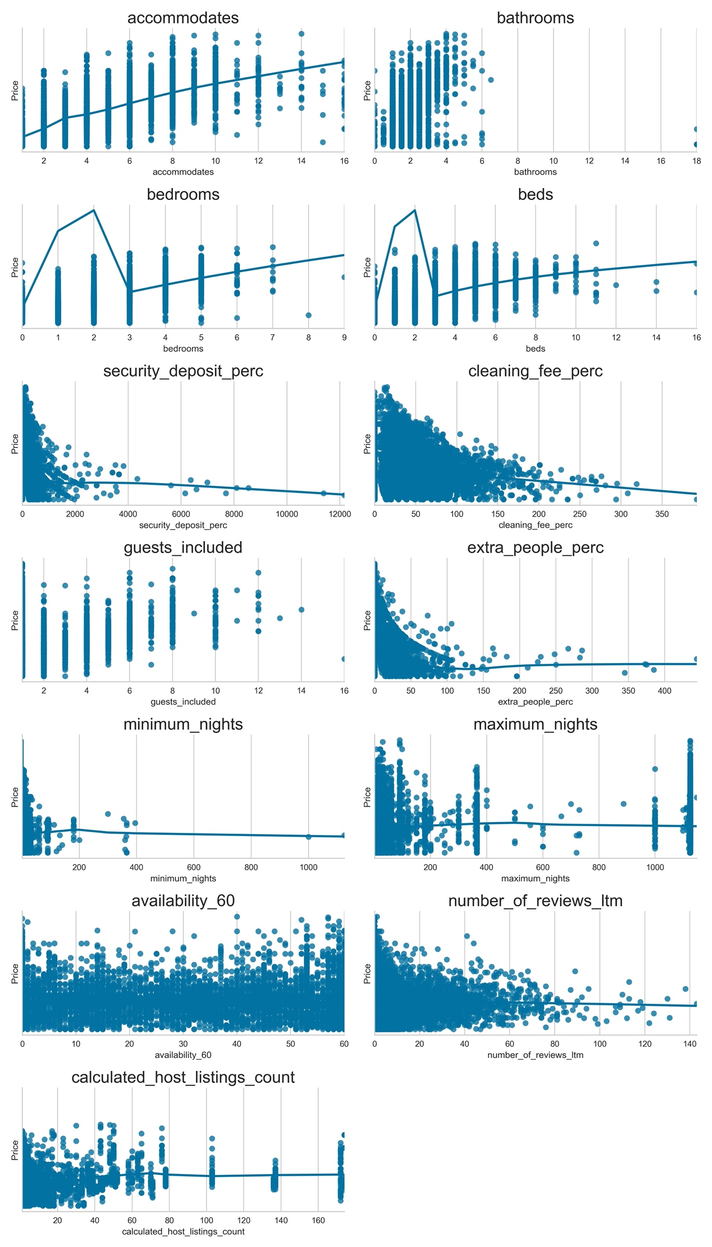

**Appendix K: Correlation heatmap between numerical explanatory variables and price**

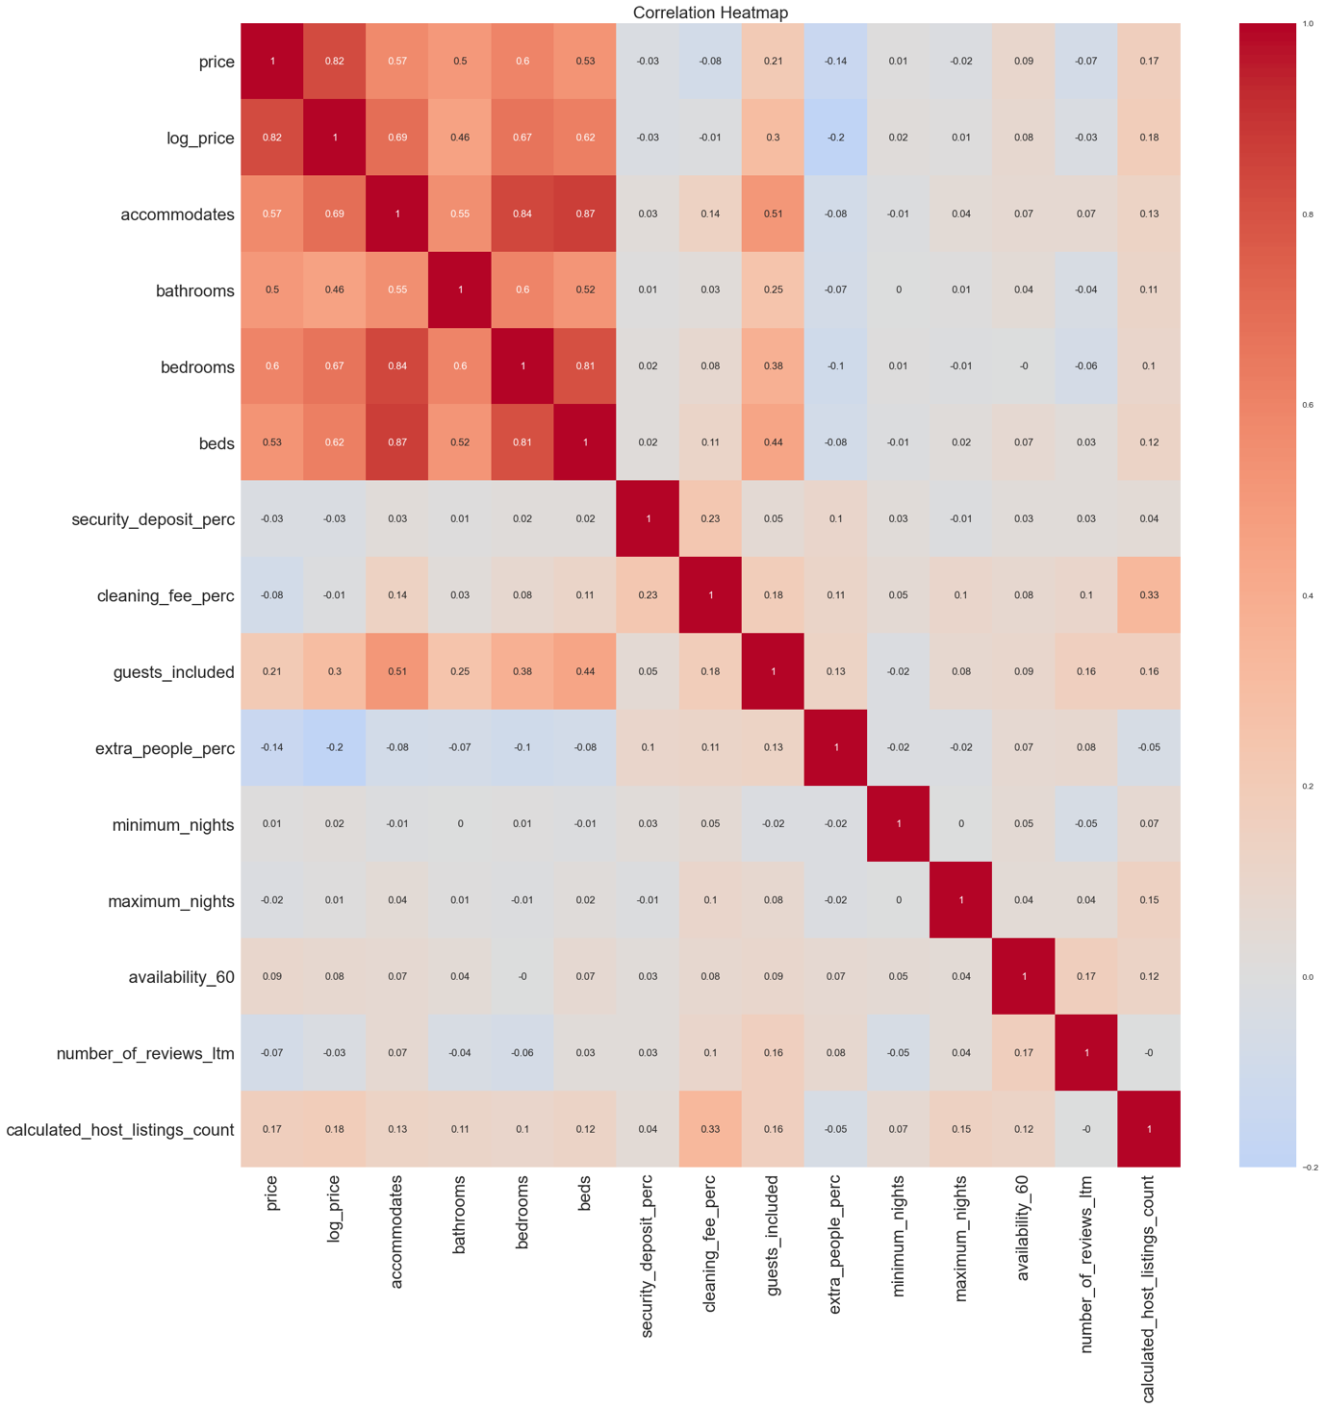

**Appendix L: Bar charts for categorical variables**

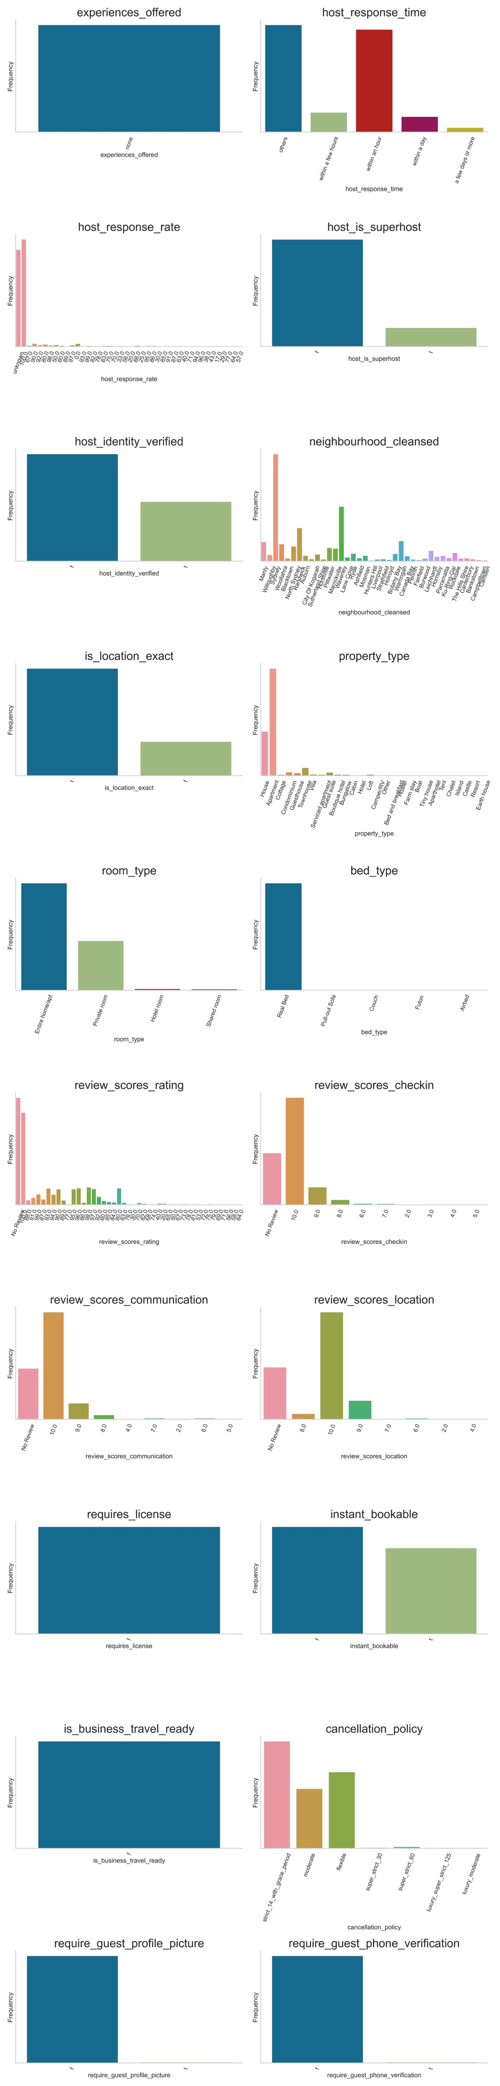

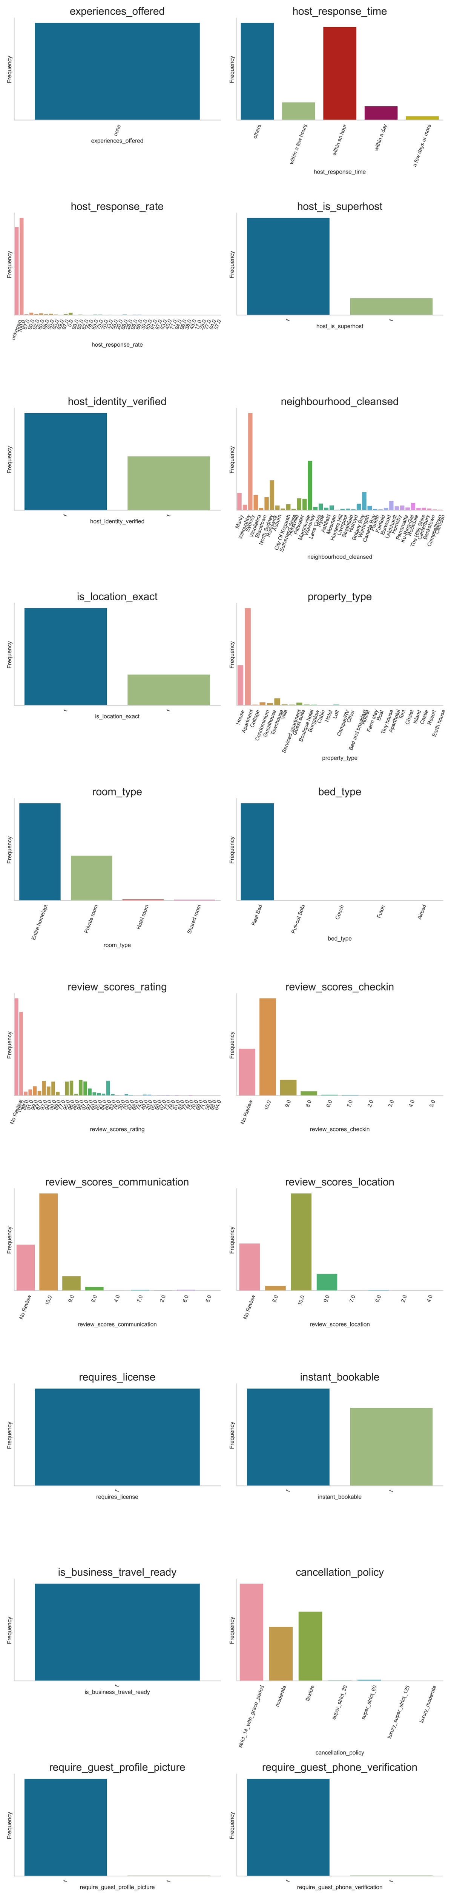

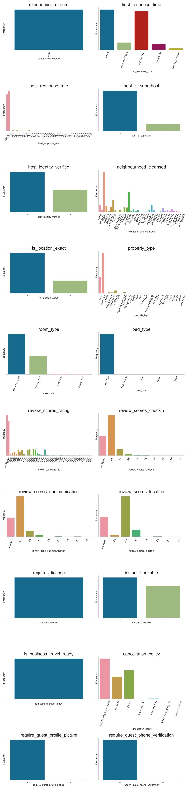

**Appendix M: Boxplots for categorical variables with price**

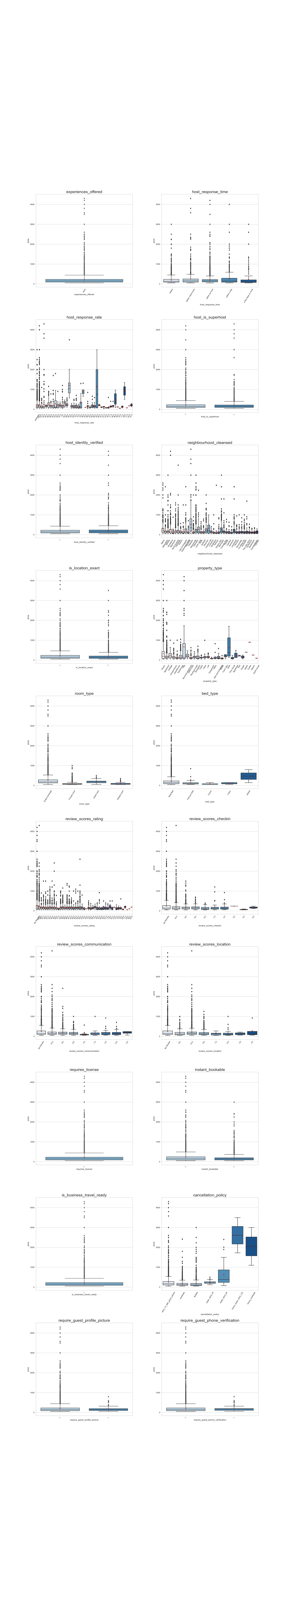

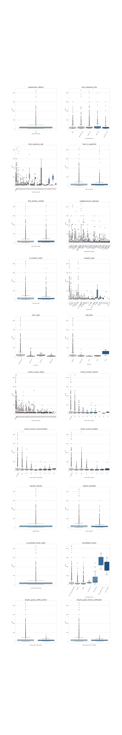

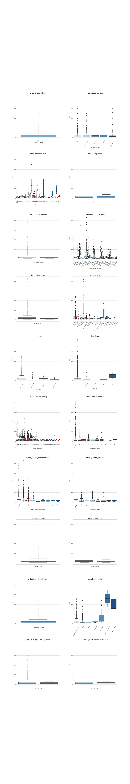

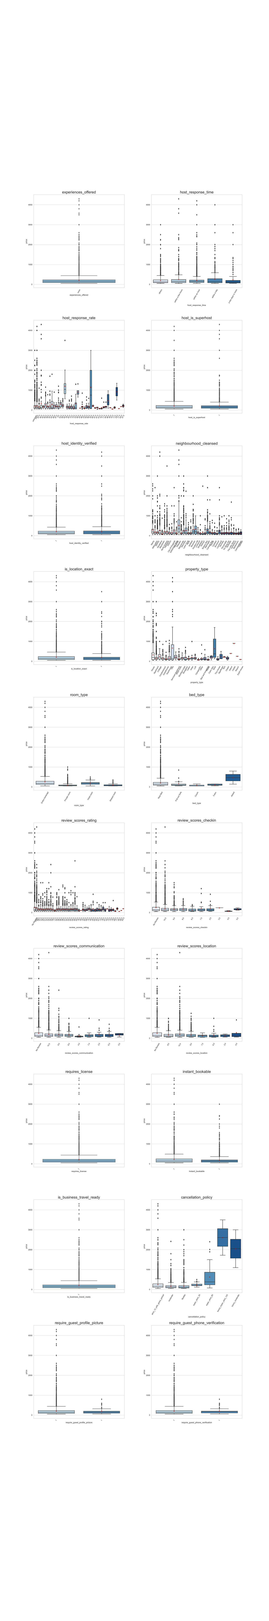

**Appendix N: Top 30 most frequent amenities**

|  |  |
| --- | --- |
| Amenities | Count |
| Kitchen | 10,096 |
| Essentials | 10,005 |
| WIFI | 9,857 |
| Washer | 9,698 |
| Smoke detector | 9,566 |
| TV | 9,022 |
| Hangers | 8,717 |
| Iron | 8,136 |
| Shampoo | 7,420 |
| Hair dryer | 7,395 |
| Dryer | 7,053 |
| Laptop friendly workspace | 6,882 |
| Heating | 6,745 |
| Hot water | 5,850 |
| Air conditioning | 5,330 |
| Refrigerator | 4,868 |
| Dishes and silverware | 4,838 |
| Free parking on premises | 4,856 |
| Microwave | 4,441 |
| Stove | 4,307 |
| Cooking basics | 4,258 |
| Oven | 4,138 |
| Bed linens | 3,996 |
| First aid kit | 3,351 |
| Fire extinguisher | 3,275 |
| Private entrance | 3,226 |
| Family/kid friendly | 3,193 |
| Free street parking | 3,168 |
| Patio or balcony | 3,150 |
| Dishwasher | 3,124 |

**Appendix O: Top 30 most frequent words in interaction, neighbourhood overview and transit**

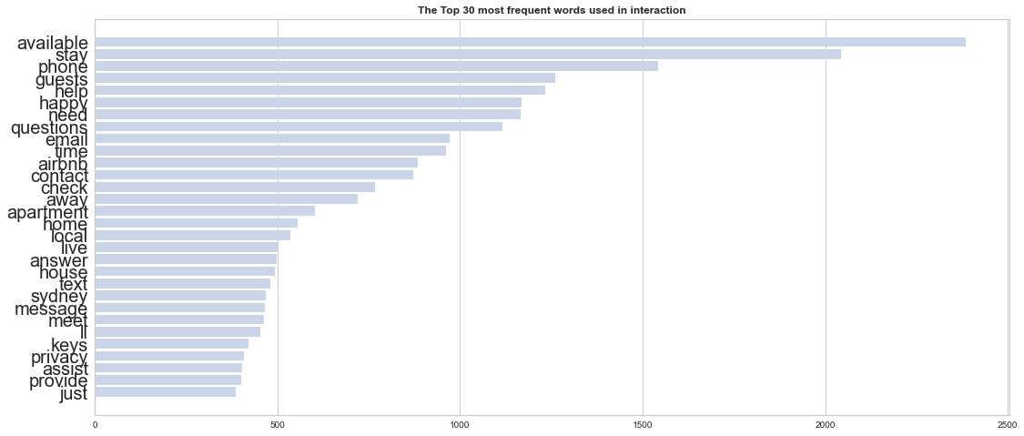

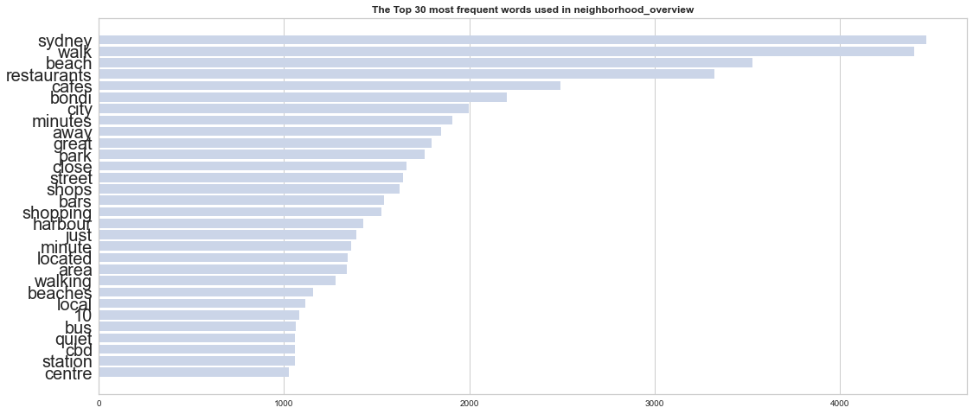

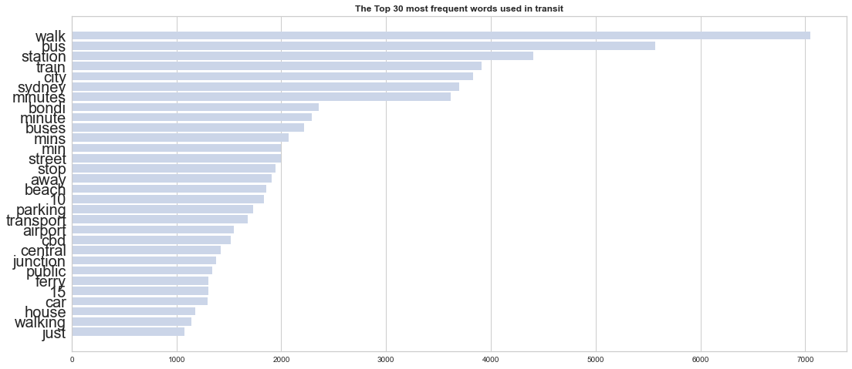

**Appendix P: Bar chart of host since**

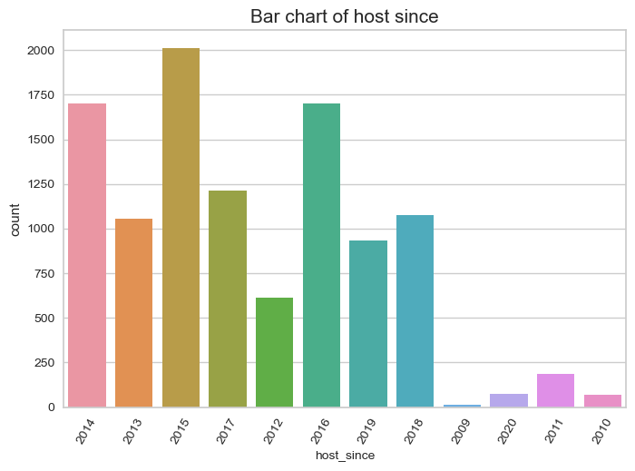

**Appendix Q: Boxplot for host since vs. price**

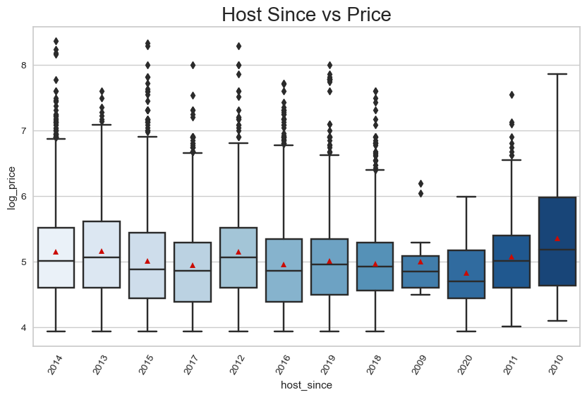

**Appendix R: Amenities Classification Table**

|  |  |
| --- | --- |
| Created Variable Name | Included Amenities |
| 'event' | 'Suitable for events' |
| 'exercise' | 'Exercise equipment’,‘Gym' |
| ‘washers’ | 'Dishwasher‘, ‘Dryer’ , ‘Washer' |
| ‘cookingbasics’ | ‘Cooking basics’ |
| ‘coffee_machine’ | ‘Coffee maker’, ‘Espresso machine’ |
| ‘bbq’ | ‘BBQ grill’, ‘Fire pit’, ‘Propane barbeque’ |
| 'kitchen' | 'Kitchen’, ‘Outdoor kitchen' |
| 'Laptop friendly workspace' | 'Laptop friendly workspace' |
| 'Toilet paper' | 'Toilet paper' |
| 'Sanity' | 'Body Soap’, ‘Shampoo' |
| 'TV' | 'TV’, ‘Smart TV’, ‘Cable TV' |
| 'Bed related' | 'Bed linens' |
| 'air conditioning' | 'Heating, ‘Air Conditioning’, ‘Central air conditioning' |
| 'Hair dryer' | 'Hair dryer' |
| 'Breakfast' | 'Breakfast' |
| 'wifi' | 'Wifi’, ‘Pocket Wifi' |
| 'check_in' | 'Self check_in’, ‘24-hour check-in' |
| 'Parking' | 'Driveway parking’, ‘Free parking on premises’, ‘Free Street parking’, ‘Garage parking’, ‘Paid Parking off premises’, ‘Paid parking on premises’, ‘Outdoor parking' |
| 'Pet-friendly' | 'Pets allowed, ‘Pets live on this property’ ,’Other pet(s)',’Cat(s)’,’Dog(s)' |
| 'Safe Facilities' | 'Smoke detector’, ‘Carbon monoxide detector’, ‘Fire extinguisher, ‘First aid kit' |
| 'Accessibility' | 'Accessible-height bed’, ‘Accessible-height toilet’ ‘Wheelchair accessible’, ‘Step-free shower’, ‘Disabled parking spot’ ‘No stairs or steps to enter' |
| Kid_friendly' | 'Baby bath’, ‘Baby monitor’, ‘Babysitter recommendations’, ‘Crib’, ‘Highchair’, ‘Children’s books and toys’, ‘Children’s dinnerware' |
| 'balcony' | 'Balcony’, ‘Patio' |
| 'nature_and_views' | 'Beach view’, ‘Beachfront’, ‘Lake access’, ‘Mountain view’, ‘Ski-in/Ski-out’, ‘Waterfront' |
| 'Smoking allowed' | 'Smoking allowed' |

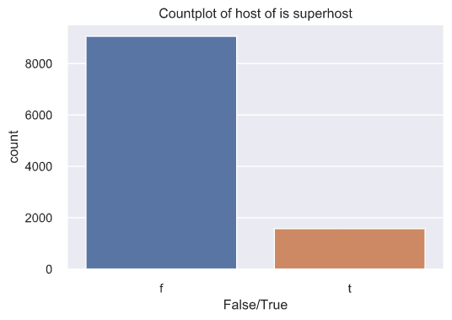**Appendix S: Countplot of host is a superhost**

**Appendix T: Logistics Regression fitted line plot for numerical explanatory variables with host is superhost**

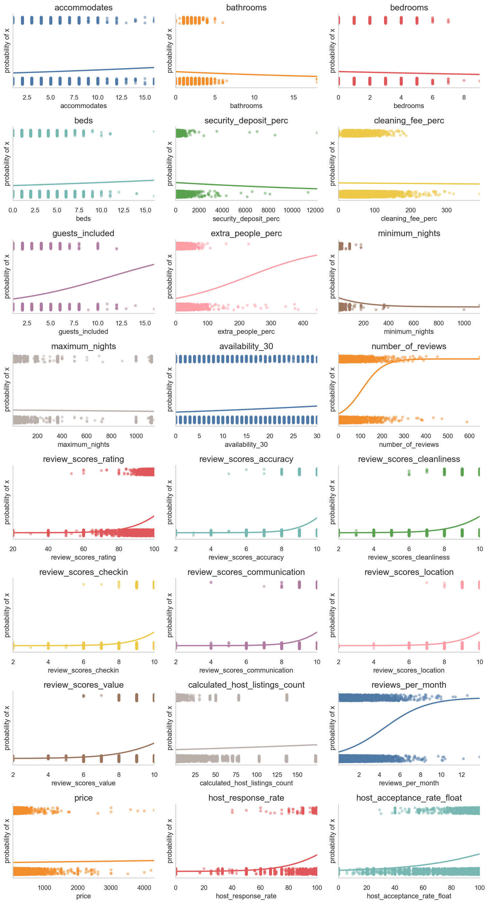

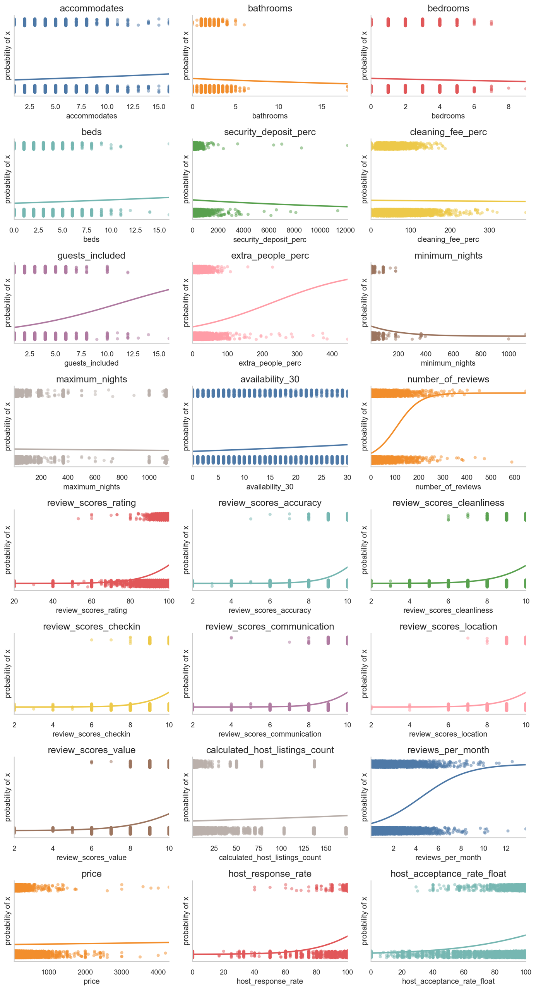

**Appendix U: Table plot for categorical explanatory variables with host is superhost**

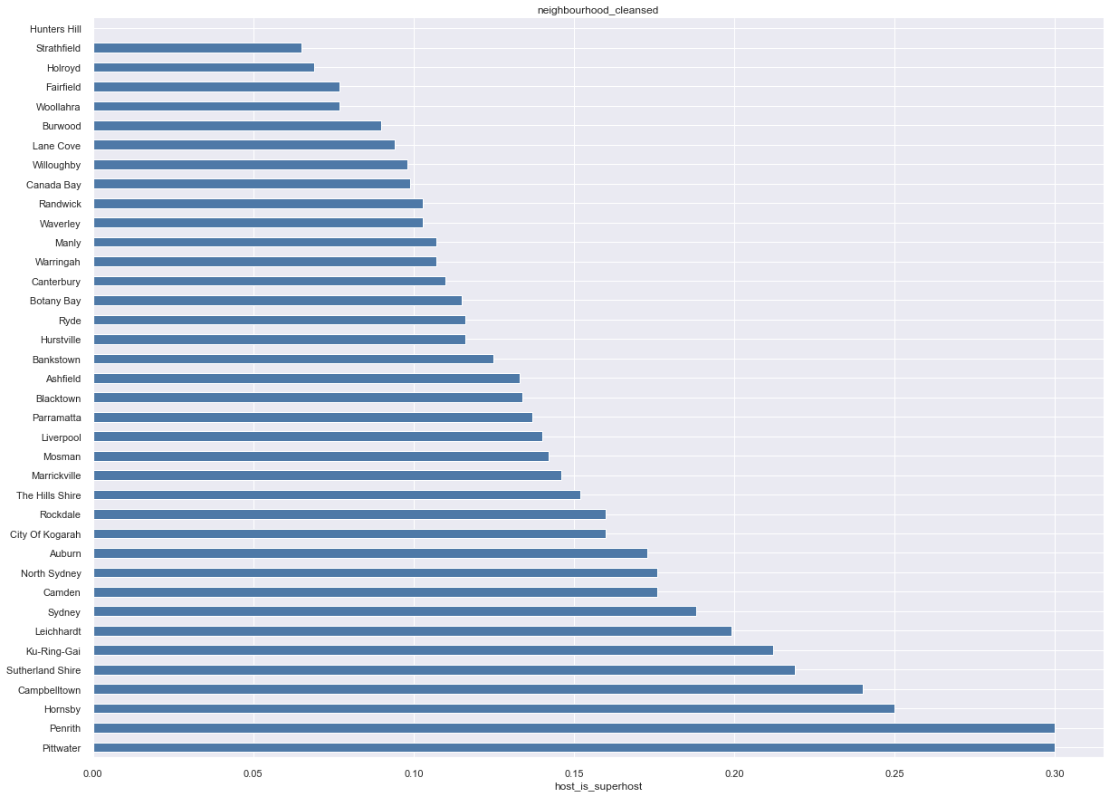

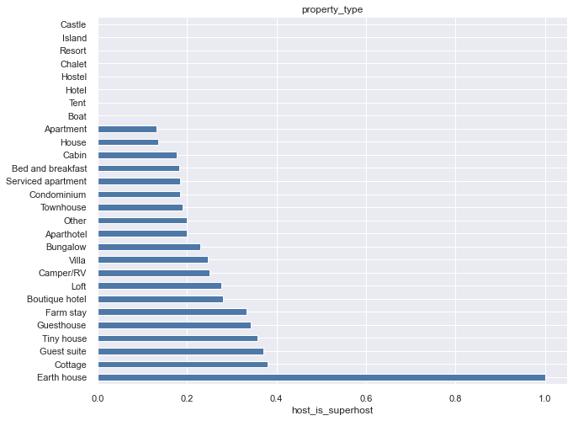

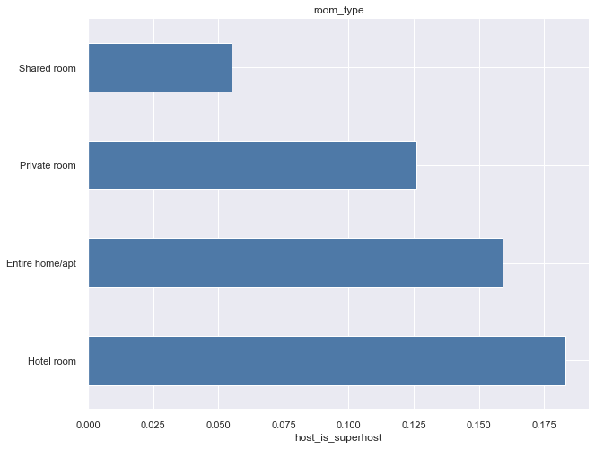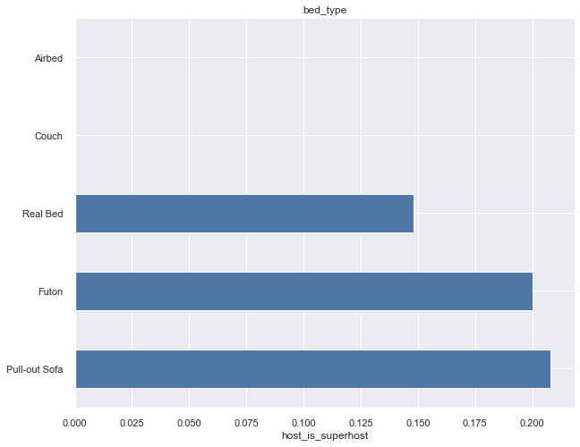

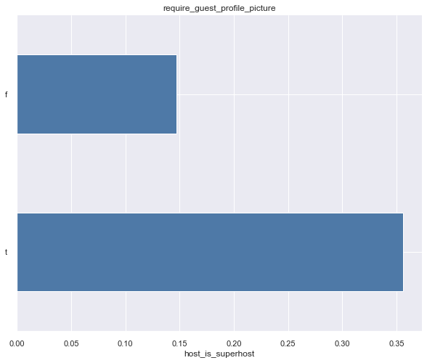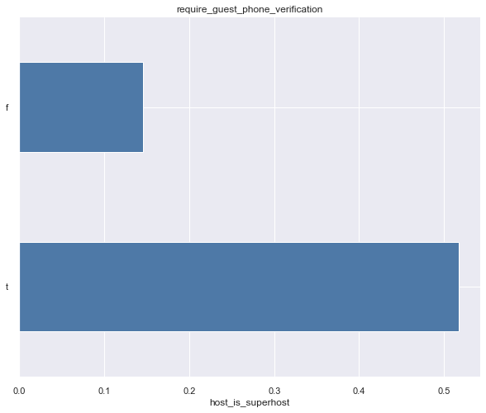

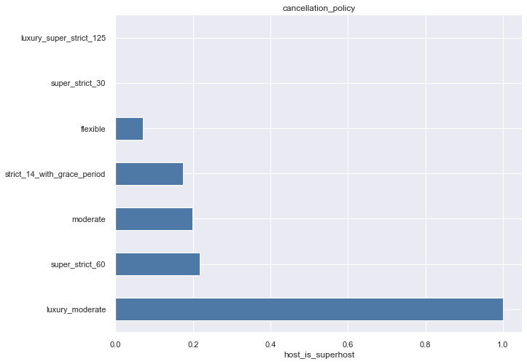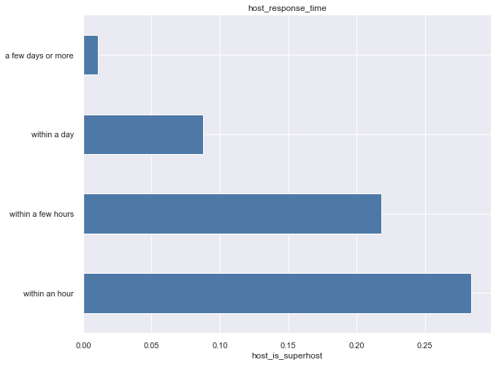

**Appendix V: Feature engineering on neighbourhoods cleansed**

|  |  |
| --- | --- |
| Encoded label | Neighbourhoods |
| 0 | Strathfield, Holroyd, Hunters Hill, Fairfield, Woollahra |
| 1 | Burwood, Lane Cove, Willoughby, Canada Bay, Randwick, Waverley, Manly, Warringah, Canterbury, Botany Bay, Ryde, Hurstville |
| 2 | Bankstown, Ashfield, Blacktown, Parramatta, Liverpool, Mosman, Marrickville, The Hills Shire, Rockdale, City of Kogarah, Auburn, North Sydney, Camden |
| 3 | Sydney |
| 4 | Leichhardt, Ku-Ring-Gai, Sutherland Shire, Campbelltown, Hornsby, Penrith, Pittwater |

**Appendix W: Feature engineering on cancellation policy**

|  |  |
| --- | --- |
| Encoded labels | Cancellation policy |
| 0 | super_strict_30, flexible |
| 1 | strict_14_with_grace_period |
| 2 | moderate, super_strict_60, luxury_super_strict_125, luxury_moderate |

**Appendix X: List of features used for final classification**

|  |  |  |
| --- | --- | --- |
| 'host_is_superhost' | ‘room_type’ | ‘bed_type’ |
| ‘monthly_discount’ | ‘security_deposit_perc’ | ‘cleaning_fee_perc’ |
| ‘extra_people_perc’ | ‘minimum_night’ | ‘maximum_night’ |
| ‘number_of_reviews’ | ‘review_socores_rating’ | ‘review_score_accuracy’ |
| ‘review_score_checkin’ | ‘review_score_communication’ | ‘review_score_location’ |
| ‘require_guest_profile_picture’ | ‘require_guest_phone_verfication’ | ‘laptop friendly work space’ |
| ‘weekly_discount’ | ‘host_acceptance_rate_float’ | ‘toilet paper’ |
| ‘guests_included’ | ‘neighbourhood_cleansed_bins’ | ‘sanity’ |
| ‘avaliability_30’ | ‘cancelatioan_policy_bins’ | ‘TV’ |
| ‘review_score_cleanliness’ | ‘event’ | ‘bed related’ |
| ‘review_scores_value’ | ‘AC_prox_essential’ | ‘air conditioning’ |
| ‘claculated_host_listing_count’ | ‘washer’ | ‘hair dryer’ |
| ‘review_per_month’ | ‘cookingbasics’ | ‘breakfast’ |
| ‘price’ | ‘coffee_machine’ | ‘wifi’ |
| ‘host_response_time’ | ‘bbq’ | ‘check_in’ |
| ‘host_response_rate’ | ‘kitchen’ | ‘Parking’ |
| ‘pet-friendly’ | ‘safe facilities’ | ‘accessibility’ |
| ‘kid_friendly’ | ‘balcony’ | ‘nature_and_review’ |
| ‘smoking allowed’ | ‘host_since_age’ | ‘host_interaction’ |
| ‘exercise’ | ‘pubilic_transport’ |  |